**HANOI UNIVERSITY OF SCIENCE AND TECHNOLOGY**

**FINE-GRAINED IMAGE CLASSIFICATION USING TRANSFER LEARNING AND CONTINUAL LEARNING**



**Introduction guide: Vu Hai**

**Students perform: Vuong Minh Hieu**

**Student ID: 20212542**

**Subject: Graduation project**

**Ha Noi, 15th  February 202****6**

Table of Contents

CHAPTER I: INTRODUCTION 6

1. Problem Statement 6

2. Project Objectives 7

3. Methodology 7

4. Scientific and Practical Significance 9

CHAPTER II: THEORETICAL BACKGROUND AND RELATED WORK 10

1. Convolutional Neural Network (CNN), EfficientNet and Transfer Learning 10

1.1 Basic CNN Architecture 10

1.2 EfficientNet 10

1.3. Transfer Learning 13

2. Continual Learning 13

2.1. Replay technique 14

2.2. Knowledge Distillation 14

2.2.1. Logit Distillation 17

2.2.2. Feature Distillation 18

2.2.3 Hard Loss ($LCE$) 19

2.2.4. Total Loss 19

3. Related Work 20

3.1 Transfer Learning with EfficientNet Architecture 20

3.2. Continual Learning and Catastrophic Forgetting 20

3.3. Knowledge Distillation in Incremental Learning 21

CHAPTER III: PROPOSED METHODOLOGY 22

1. System Overview 22

1.1. Phase 1: Base Training via Transfer Learning 22

1.2. Phase 2: Continual Learning via Knowledge Distillation 22

2. Dataset 23

2.1. Butterfly & Moth Image Classification 100 species (Kaggle) 23

2.1.1. Butterfly & Moth Image Classification 100 species (self – collected) 24

2.1.2. Data Specification Summary Table 24

2.1.3. Data Preprocessing 25

2.1.4. Phase 1: Building the Baseline Model (Transfer Learning) 26

2.1.5. Phase 2: Continual Learning with Knowledge Distillation 27

2.2. Pollen Grain Classification dataset (VNUA and Dong Van) 32

2.2.1. Hyperparameter setup for Continual Learning 33

CHAPTER IV: EXPERIMENT RESULTS AND ANALYSIS 37

1. Experimental Setup 37

2. Case Study I: Butterfly & Moth Image Classification 100 species 37

2.1 Transfer Learning Results 37

2.2 Continual Learning Results 39

2.3 Model F1-Scores on Dataset 2 40

2.4. Metrics Comparision Table 42

3. Case Study II: Pollen Grain Classification 42

3.1. Transfer Learning Results 42

3.2 Continual Learning Results 43

3.2.1 Model 2 43

3.2.2 Model 3 44

3.3 Metrics Comparision Table 45

CHAPTER V: DEPLOYMENT 46

1. Introduction 46

2. Technology Stack 46

3. System Architecture 46

4. Main Features of the Application 47

5. Demo 47

CHAPTER VI: CONCLUSION AND FUTURE WORK 50

1. Conclusion 50

2. Limitations 50

3. Future Work 51

References 52

**List of Figures**

Fig 1: Two similar butterfly species, demonstrating the challenge of fine-grained classification (Eastern Dappled White and Large Marble) 6

Fig 2: Diagram of the two-phase learning strategy 8

Fig 3: CNN Architecture 10

Fig 4: Model Scaling changes with a baseline example 11

Fig 5: Accuracy changes with tuning both d and r. 12

Fig 6: Architecture of EfficientNet-B0 12

Fig 7: The specific architecture of the benchmark knowledge distillation (Hinton et al., 2015) 15

Fig 8: Types of knowledge distillation 16

Fig 9: Proposed Training Pipeline with Transfer Learning and Knowledge Distillation 23

Fig 10: Data Preprocessing code 25

Fig 11: Images before and after data preprocessing 26

Fig 12: Transfer Learning with EfficientNet-B0 code 26

Fig 13: Fine-tuning code 27

Fig 14: The Logits Distillation Class 28

Fig 15: The Feature Distillation Class 29

Fig 16: Total Loss computation code 30

Fig 17: Hyperparameter configuration for Butterfly dataset 31

Fig 18: Task 1 Hyperparameter Configuration for the Pollen Grain Dataset 33

Fig 19: Hyperparameter Configuration for iteration 1 34

Fig 20: Hyperparameter Configuration for iteration 2 35

Fig 21: Hyperparameter Configuration for iteration 3 36

Fig 22: Model 1 accuracy on Dataset 1 (Butterfly) 37

Fig 23: Loss Chart of Butterfly dataset 37

Fig 24: Accuracy Chart of Butterfly dataset 38

Fig 25: F1-score Chart 38

Fig 26: Lowest F1-score species Table 39

Fig 27: Chalk Hill Blue and Adonis 39

Fig 28: Purlish Copper 39

Fig 29: Model 1 accuracy on Dataset 2 (Butterfly) 40

Fig 30: Model 2 accuracy on Dataset 1 & 2 40

Fig 31: Model F1-Scores on Dataset 2 Table 41

Fig 32: Metrics Comparision Table (Butterfly Dataset) 42

Fig 33: Model’s training time (Butterfly Dataset) 42

Fig 34: Model 1 accuracy on Dataset 1 (Pollen Grain) 42

Fig 35: Accuracy Chart of Pollen Grain dataset 43

Fig 36: Loss Chart of Pollen Grain dataset 43

Fig 37: Model 1 accuracy on Dataset 2 (Pollen Grain) 44

Fig 38: Model 2 accuracy on Dataset 2 (Pollen Grain) 44

Fig 39: Model 2 accuracy on Dataset 1 (Pollen Grain) 44

Fig 40: Model 3 accuracy on Dataset 3 & 1 (Pollen Grain) 44

Fig 41: Metrics Comparision Table (Pollen Grain Dataset) 45

Fig 42: Model’s training time (Pollen Grain Dataset) 45

Fig 43: User Interface of the Butterfly Species Prediction Application 47

Fig 44: Input Interface for Image Uploading and Pre-processing 48

Fig 45: Classification Results Displaying Species Name and Confidence Score. 49

**ABSTRACT**

Fine-Grained Visual Classification (FGVC) poses a significant challenge in computer vision, requiring the discrimination of subtle visual differences among visually similar sub-categories. A critical limitation in deploying such systems for real-world applications, such as biodiversity monitoring, is the "catastrophic forgetting" phenomenon, where deep learning models tend to lose previously acquired knowledge when adapting to new data streams. Addressing these challenges, this project proposes a robust classification framework that integrates Transfer Learning and Continual Learning. Initially, the EfficientNet-B0 architecture was employed as a backbone to leverage its efficiency and high feature extraction capabilities on the dataset. To mitigate forgetting, a Continual Learning strategy was implemented using a combination of Knowledge Distillation and Replay techniques. Knowledge Distillation helps preserve the soft labels of the previous tasks, while Replay maintains a small buffer of old samples to reinforce past knowledge. Experimental results demonstrate that the proposed method achieves high accuracy across both old and new species, proving its robustness and scalability for incremental biodiversity monitoring applications.

**Keywords:** Fine-Grained Visual Classification, EfficientNet-B0, Transfer Learning, Continual Learning, Knowledge Distillation, Replay.

# 

# CHAPTER I: INTRODUCTION

## 1. Problem Statement

**Fine-Grained Visual Classification** (**FGVC**) stands as a significant challenge in modern computer vision, requiring the discrimination of subtle visual differences among visually similar sub-categories. A critical application of this domain is biodiversity monitoring, specifically the identification of insect species such as butterflies and moths,… which serve as vital environmental indicators and pollinators.

Due to the vast diversity of thousands of species, manual classification based on morphology requires in-depth taxonomic expertise and is highly time-consuming. The emergence of Deep Learning, particularly Convolutional Neural Networks (CNNs), has provided a robust solution for automating this process with high accuracy.

The figure below two different butterfly species with very similar morphologies, which can easily cause confusion even for experts.

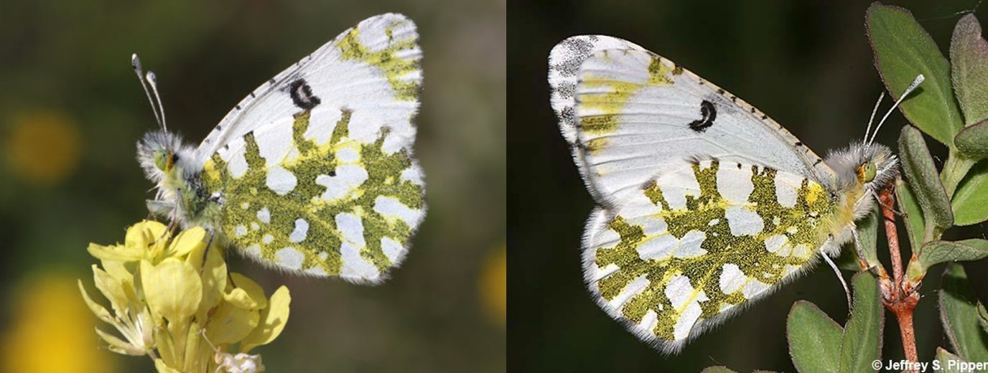

Fig 1: Two similar butterfly species, demonstrating the challenge of fine-grained classification (Eastern Dappled White and Large Marble)

However, in reality, AI systems often face two major challenges:

1. **Data and Resource Scarcity:** Training a model from scratch requires a massive amount of data and high computational costs.
2. **Continuous Data and Environmental Evolution (Domain Shift):** When new species are discovered, or when existing species are re-collected under different lighting, camera angles, and backgrounds, retraining the entire model becomes impractical. If trained only on the new data, the model will suffer from **Catastrophic Forgetting**—losing the ability to accurately recognize previously learned species or failing to adapt to variations in the photographic environment.

## 2. Project Objectives

The project focuses on developing an intelligent classification system for fine-grained tasks, with the capability for flexible knowledge expansion. The specific objectives include:

* **Building a Foundation Model:** Utilizing the **EfficientNet-B0** architecture and **Transfer Learning** techniques to achieve high accuracy on the initial dataset.
* **Addressing the New Data Learning Problem:** Implementing a **Continual Learning** mechanism to update the model when receiving new datasets without the need for retraining from scratch.
* **Preventing Catastrophic Forgetting and Stabilizing Recognition:** Ensuring that the model maintains high performance on previously learned species after further training. Simultaneously, the system must achieve high accuracy on new species and remain robust against variations in camera angles and lighting conditions across the entire dataset.

## 3. Methodology

The project is conducted through two consecutive phases:

**Phase 1: Base Training**

* Utilizing the **EfficientNet-B0** model, pre-trained on ImageNet, as the backbone architecture.
* Applying **Transfer Learning** to train the model on the **first dataset**, helping the network familiarize itself with the morphological features, colors, and patterns of the new species.

**Phase 2: Continual Learning**

* When the **second dataset** (containing new image) is introduced, instead of retraining the entire model, the project updates the network weights based on the model from Phase 1.
* Utilizing a combination of two core techniques:
  + **Knowledge Distillation:** Treating the Phase 1 model as the "Teacher" to supervise the learning process of the "Student" model in Phase 2. The project applies distillation mechanisms at two levels to optimize the knowledge transfer from the old model to the new one:
    - **Logit Distillation:** Comparing output probability distributions to preserve the decision boundaries of old species.
    - **Feature Distillation:** Constraining the intermediate feature layers (bottleneck layers) of the Student model to produce feature vectors similar to the Teacher, helping to preserve the semantic information and patterns learned from Dataset 1**.**
  + **Replay:** Maintaining an **Exemplar Buffer** containing representative image samples from the first dataset. These samples are trained in parallel with the new data to continuously reinforce previously learned knowledge.

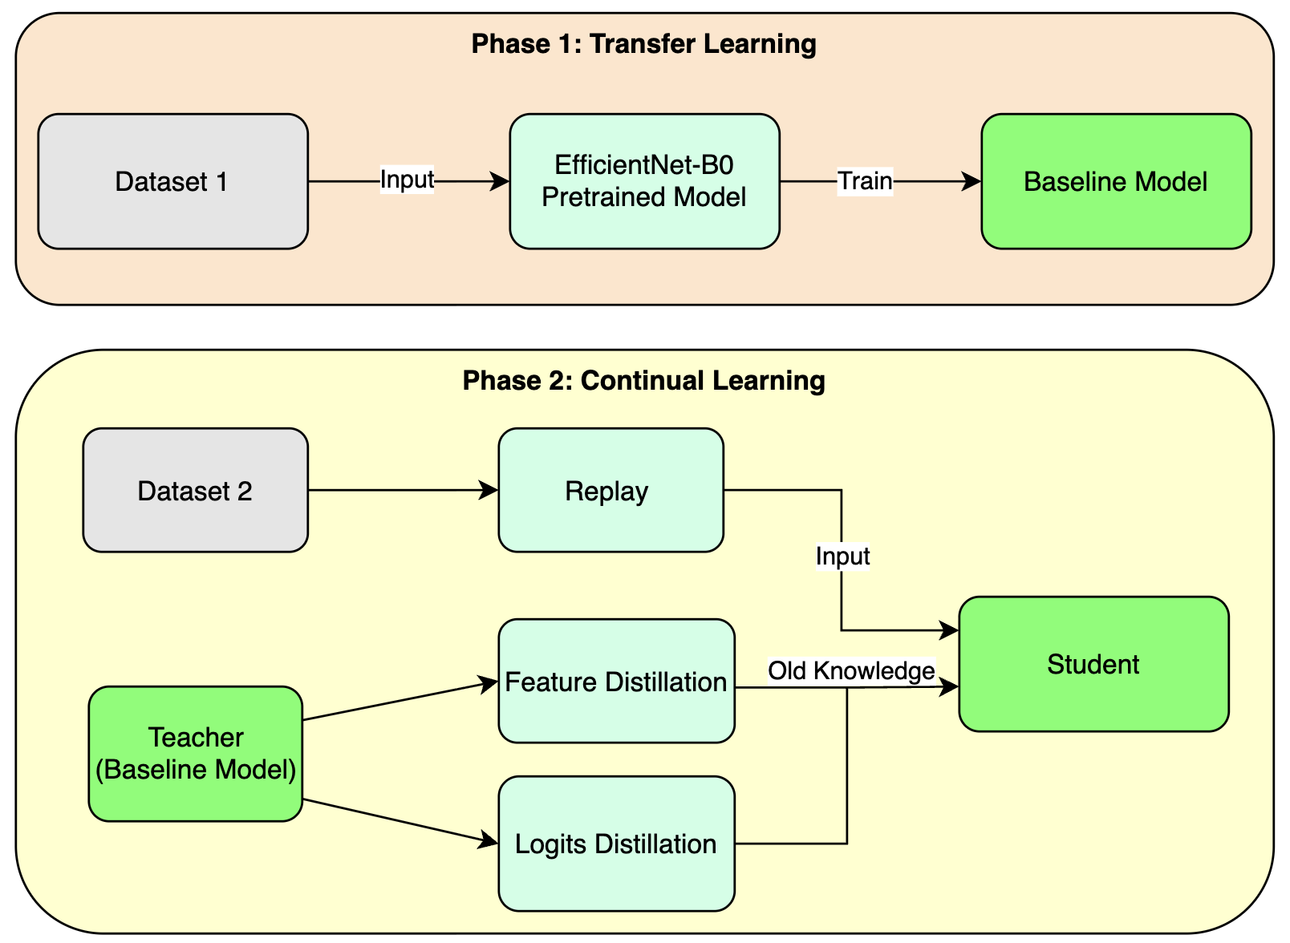

Fig 2: Diagram of the two-phase learning strategy

## 

## 4. Scientific and Practical Significance

* **Scientifically:** Experimenting with the effectiveness of combining a modern network architecture (EfficientNet) with anti-forgetting algorithms in real-world image classification problems.
* **Practically:** Creating a foundation for intelligent biodiversity monitoring applications capable of updating knowledge over time without requiring excessive server resources for full retraining.

# 

# 

# CHAPTER II: THEORETICAL BACKGROUND AND RELATED WORK

## 1. Convolutional Neural Network (CNN), EfficientNet and Transfer Learning

### 1.1 Basic CNN Architecture

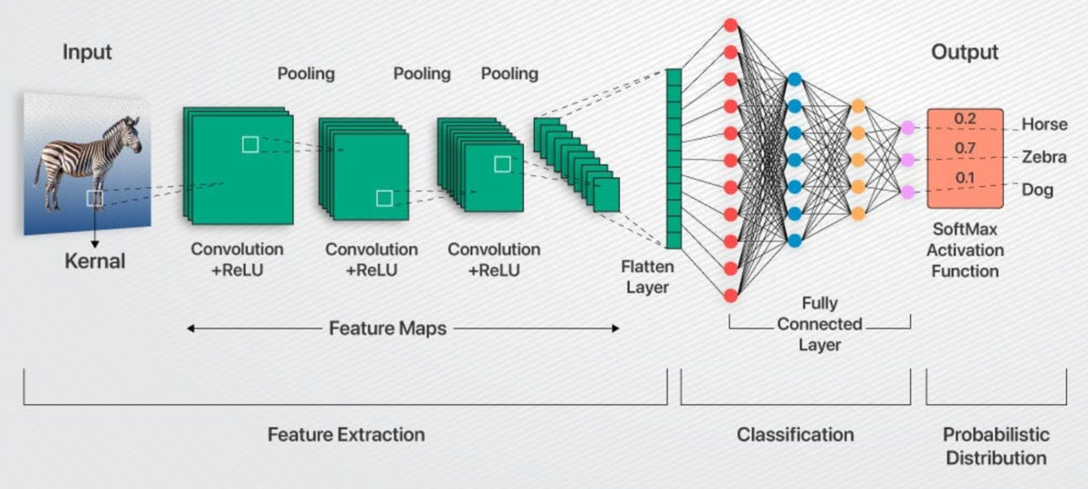

Fig 3: CNN Architecture

**Input Layer:** Receives the input image.

**Convolution Layer + ReLU:** Extracts non-linear features.

**Pooling Layer:** Reduces data dimensionality while retaining important features.

**Flatten Layer:** Converts spatial features into a 1D vector.

**Fully Connected Layer:** Calculates probabilities based on the flattened vector.

**Output Layer (Softmax):** Produces the final result.

### 1.2 EfficientNet

***Note:*** *The following technical descriptions of the EfficientNet architecture are synthesized from the original research paper by Tan & Le [1] and technical documentation provided by Roboflow [2].*

EfficientNet is a convolutional neural network built upon a concept called "compound scaling". This concept addresses the longstanding trade-off between model size, accuracy, and computational efficiency. The idea behind compound scaling is to scale three essential dimensions of a neural network: width, depth, and resolution.

1. **Width:** Width scaling refers to the number of channels in each layer of the neural network. By increasing the width, the model can capture more complex patterns and features, resulting in improved accuracy. Conversely, reducing the width leads to a more lightweight model, suitable for low-resource environments.
2. **Depth:** Depth scaling pertains to the total number of layers in the network. Deeper models can capture more intricate representations of data, but they also demand more computational resources. On the other hand, shallower models are computationally efficient but may sacrifice accuracy.
3. **Resolution:** Resolution scaling involves adjusting the input image's size. Higher-resolution images provide more detailed information, potentially leading to better performance. However, they also require more memory and computational power. Lower-resolution images, on the other hand, consume fewer resources but may lead to a loss in fine-grained details.

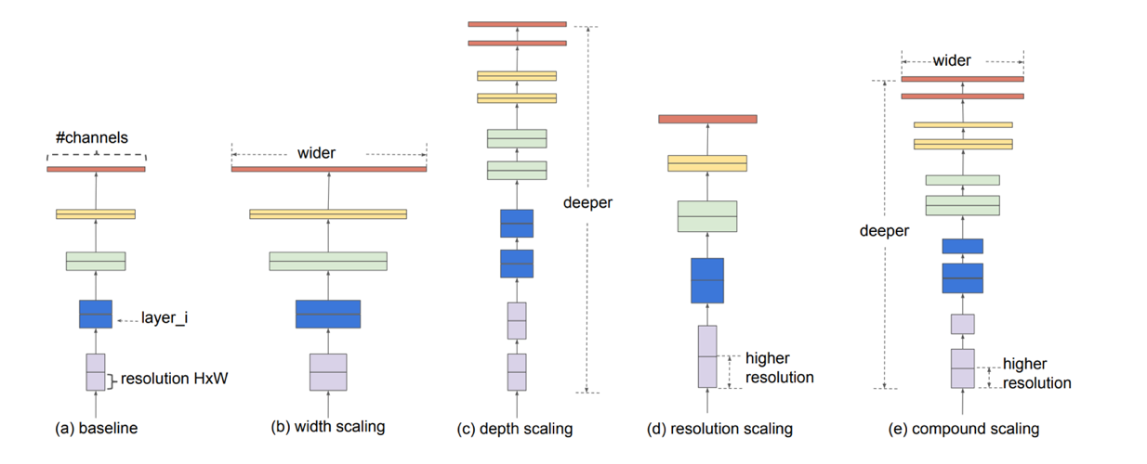

Fig 4: Model Scaling changes with a baseline example

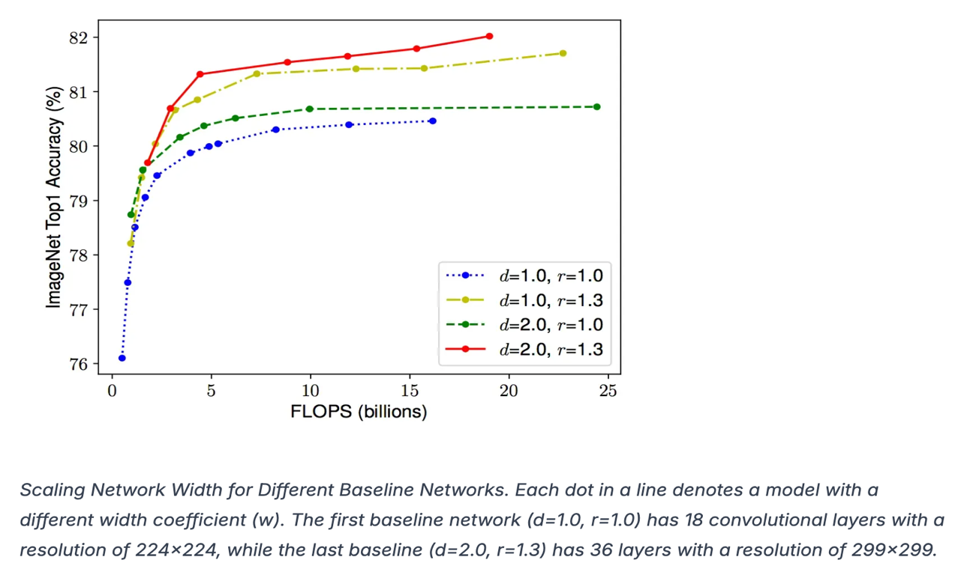

Fig 5: Accuracy changes with tuning both d and r.

**EfficientNet Architecture**

EfficientNet-B0, discovered through Neural Architectural Search (NAS) is the baseline model. The main components of the architecture are:

* **MBConv block (Mobile Inverted Bottleneck Convolution)**
* **Squeeze-and-excitation (SE) optimization**

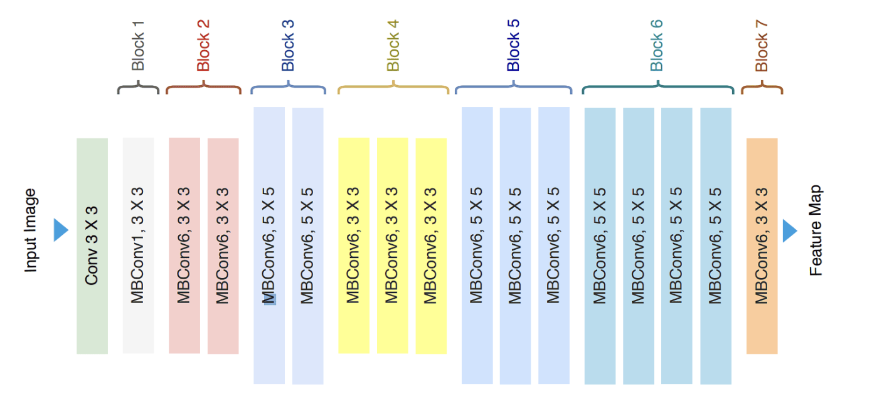

Fig 6: Architecture of EfficientNet-B0

The **MBConv layer** starts with a depth-wise convolution, followed by a point-wise convolution (1 x 1 convolution) that expands the number of channels, and finally, another 1 x 1 convolution that reduces the channels back to the original number. This bottleneck design allows the model to learn efficiently while maintaining a high degree of representational power.

In addition to **MBConv layers**, EfficientNet incorporates the **SE block**, which helps the model learn to focus on essential features and suppress less relevant ones. The **SE block** uses global average pooling to reduce the spatial dimensions of the feature map to a single channel, followed by two fully connected layers.

These layers allow the model to learn channel-wise feature dependencies and create attention weights that are multiplied with the original feature map, emphasizing important information.

EfficientNet comes in different variants, such as EfficientNet-B0, EfficientNet-B1, and so on, with varying scaling coefficients. Each variant represents a different trade-off between model size and accuracy, enabling users to select the appropriate model variant based on their specific requirements.

Using EfficientNet-B0 helps the model achieve higher accuracy while consuming fewer computational resources (FLOPs) compared to traditional networks like ResNet or VGG. It is highly suitable for fine-grained tasks with many complex details.

### 1.3. Transfer Learning

**Transfer Learning** is a technique that uses a model previously trained on a large dataset (such as ImageNet) to apply it to a new problem with similar characteristics. In this project, the learned weights of EfficientNet-B0 will be kept as a **Feature Extractor**; only the final classification layers are modified to suit the number of species.

## 2. Continual Learning

In traditional Deep Learning, when a model learns a new task (Task 2) by updating its weights, important information from the previous task (Task 1) is often completely overwritten. This leads to a sharp decline in accuracy on Task 1, a phenomenon known as **catastrophic forgetting**. In such cases, we need to apply **Continual Learning.**

**Continual Learning** is an artificial intelligence (AI) learning approach that involves sequentially training a model for new tasks while preserving previously learned tasks. Models incrementally learn from a continuous stream of nonstationary data, and the total number of tasks to be learned is not known in advance.

Incremental learning allows models to acquire new knowledge and keep pace with the unpredictability of the real world without forgetting old knowledge. Nonstationary data means that the data distributions are not static. When implemented successfully, continual learning results in models that maintain task-specific knowledge and can also generalize across dynamic data distributions.

### 2.1. Replay technique

**Replay** is a memory-based strategy. A small portion of data from previously learned species (Dataset 1) is stored in an **Exemplar Buffer**. When the model learns new species (Dataset 2), image samples from this buffer are mixed into the training process to "remind" the model of its old knowledge.

### 2.2. Knowledge Distillation

***Note:*** *The following technical descriptions regarding the mechanisms of Knowledge Distillation (KD) and their application in Continual Learning are synthesized from the seminal research by Hinton et al. [3] and practical implementation guides provided by Hugging Face [4].*

**Knowledge distillation** is a method to distill the knowledge in an ensemble of cumbersome models and compress it into a single model in order to make possible deployments to real-life applications

Knowledge distillation refers to the transfer of the learning behavior of a cumbersome model (**teacher**) to a smaller one (**student**), in which, the output produced by the teacher is used as the “soft targets” for training the student.

* **Teacher Model**: A large model, which can be a collection of separately trained models or a single large model trained with a very powerful set of parameters.
* **Student Model**: The smaller model uses distilled knowledge from a Teacher network. It utilizes a different form of training, called 'distillation', to transfer learned knowledge from the Teacher Model to itself. The Student Model is more suitable for deployment than the Teacher Model because it is less computationally expensive and provides comparable or even better accuracy than the Teacher Model (as proven by relevant research papers).

**Temperature (T)** — it is a way to control how confident or uncertain a model’s predictions are. It adjusts the sharpness of the probability distribution – making it either more confident (sharp) or more uncertain (soft). If T = 1, it is the default setting referring to the normal softmax behavior, where only the correct answer receives 100% probability. In this case, softmax creates **hard targets**. When the temperature is increased (T > 1), softmax creates **soft targets**, meaning the probabilities are more spread out or softer.

**Soft targets are useful for distillation and training, and the knowledge distillation process below shows why.** It typically involves several steps:

1. First, the teacher model is trained on the original task and dataset.
2. Next, the teacher model produces logits. These logits are converted into soft targets using a softmax function with a higher temperature to make the probability distribution softer.
3. The student model is then trained on these soft targets often alongside the hard targets (true labels) by minimizing the difference between the student’s output distribution and the teacher’s output distribution.

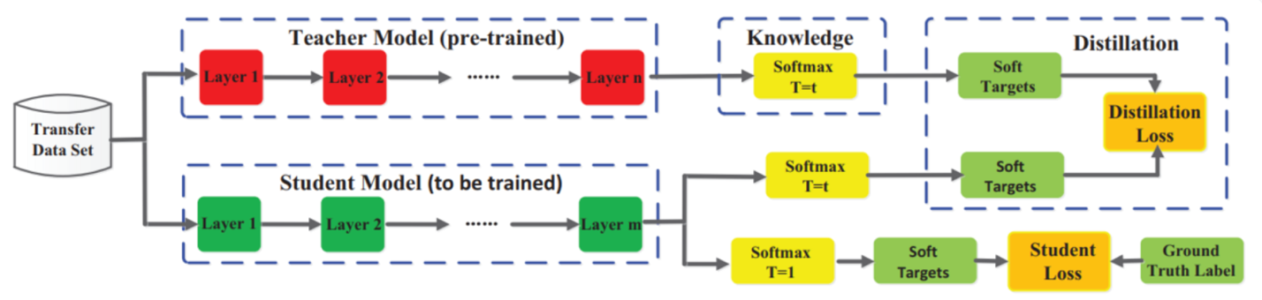

Fig 7: The specific architecture of the benchmark knowledge distillation (Hinton et al., 2015)

During this process the student learns to reproduce not just the correct answers, but also the teacher’s relative confidence in those answers and its mistakes. This knowledge about how the teacher distributes probability mass among the incorrect categories provides rich information that helps the student generalize better. By combining a standard training loss on true labels with a distillation loss on the teacher’s soft labels, the student can achieve accuracy close to the teacher model’s accuracy, despite having far fewer parameters.

If we were to summarize the key idea in one sentence, it would be this: **The student is optimized to mimic the teacher’s behavior, not just outputs.**

**Types of knowledge distillation**

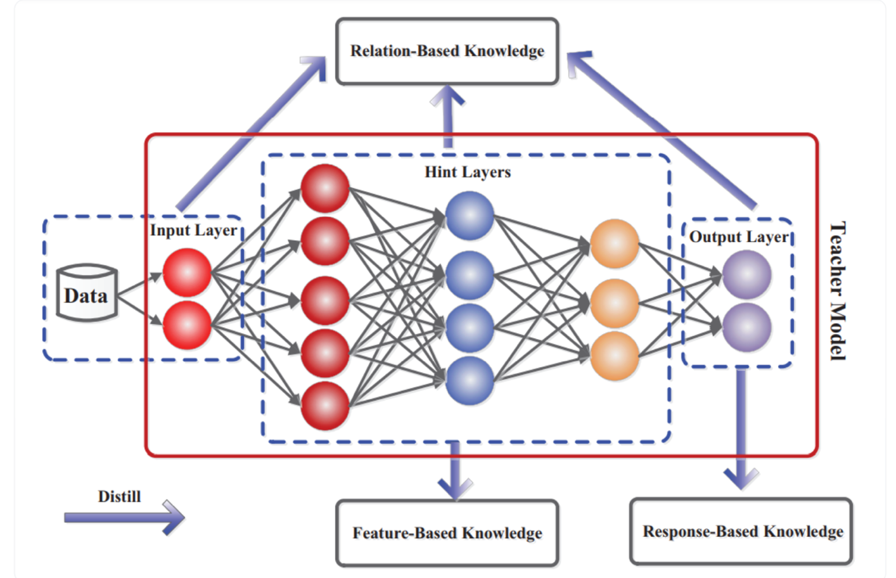

Fig 8: Types of knowledge distillation

1. **Response-based distillation (outputs as knowledge):** It is exactly what we have discussed above. This classic approach uses the teacher’s final output probabilities as the target for training the student. It works well in different AI tasks, like image classification, object detection, and pose estimation.
2. **Feature-based distillation (intermediate layers as knowledge):** Instead of only copying the final predictions, the student also learns from the intermediate layers, or feature maps, of the teacher. This idea was proposed in the ***“FitNets: Hints for Thin Deep Nets”*** paper. Think of this technique as the student learning from the teacher's step-by-step problem-solving process. The student matches its intermediate representations to those of the teacher, learning both the right answers and the reasoning behind them. Different methods, such as attention maps, probability distributions, and layer connections, help match teacher and student features. It especially improves performance in tasks like image recognition and object detection.
3. **Relation-based distillation (relationships as knowledge):** The student model learns to mimic relationships between different parts of the teacher model – either between layers or between different data samples. For example, the students compares multiple samples and learns their similarities. This method is more complex but can work with multiple teacher models, merging their knowledge.

#### 2.2.1. Logit Distillation

The goal is to help the Student learn the Teacher's 'probability distribution', thereby understanding the correlations between species (for example: species A shares more similarities with species B than with species C).

**Softmax function with temperature parameter (T):**

The Softmax function converts logits into probabilities using the formula:

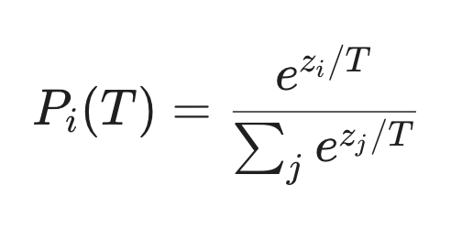

* $z_{i}$**:** The output logit of $i^{th}$ class from the model.
* $T$**:** Temperature parameter. When $T$ > 1, the probability distribution becomes "softer", helping the Student model learn more information about inter-class correlations.

**Logit Loss:**

Use the Kullback-Leibler Divergence (KL Divergence) function to measure the difference between the distributions of the Teacher and the Student:

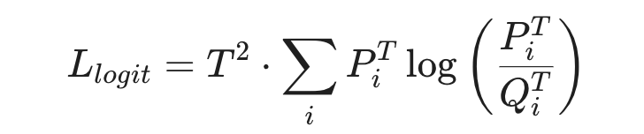

* $P_{i}^{T}$**:** Teacher’s $i^{th}$ class probability at T temperature.
* $Q_{i}^{T}$: Student’s $i^{th}$ class probability at T temperature.

#### 2.2.2. Feature Distillation

This technique forces the Student to have a perspective and feature extraction method similar to the Teacher through intermediate layers.

**Global Average Pooling**

To extract representative feature vectors and reduce data dimensionality, we apply the Global Average Pooling (GAP) operation on each feature channel, defined as follows: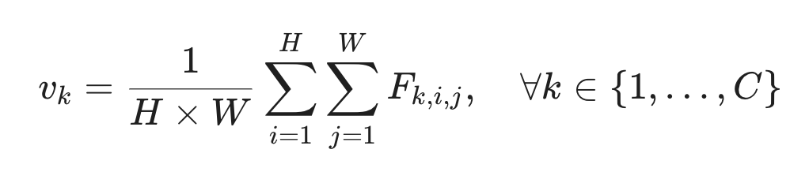

* $F_{k,i,j}$: The pixel value at channel $k,$ row $i$, and column $j$ in the original feature map (before pooling).
* $H, W$: The height and width of the feature map.
* $v:$ The feature vector derived from Global Average Pooling, capturing the global semantic context of the input image.
* $C:$ Number of channels

$L^{2}$**Normalization**

To focus on comparing the direction of the feature vectors between the Teacher and Student (representing the semantic structure) instead of their magnitude, we perform vector normalization:

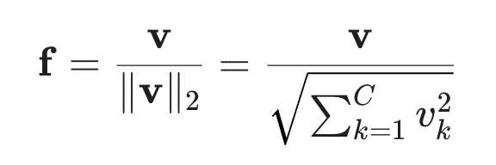

* $f:$ Normalized Feature Vector

**Feature Loss Function**

The feature loss function is defined as the Mean Squared Error (MSE) between the normalized feature vectors of the Teacher ($f^{T}$) and the Student ($f^{S}$)

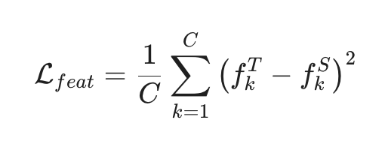

* $f^{T}:$ Normalized Feature Vector of Teacher
* $f^{S}:$ Normalized Feature Vector of Student

#### 2.2.3 Hard Loss ($L_{CE}$)

While the distillation loss helps the Student learn from the Teacher's knowledge, the **Hard Loss** ensures that the Student is still learning correctly from the actual labels. Hard Loss measures the discrepancy between the Student model's predictions and the ground truth (**Hard labels**) of the dataset. In classification tasks, this function is typically defined by **Cross-Entropy Loss**.

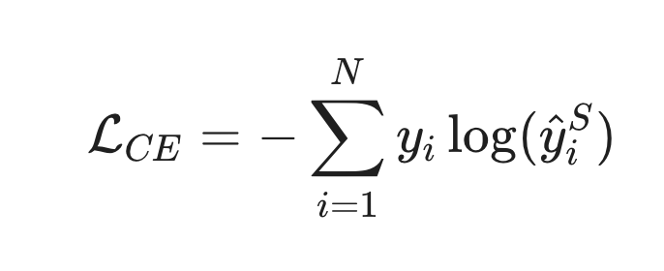

* $N$: Number of classes.
* $y_{i}$: The ground truth (actual label) of class $i$, typically represented in the form of a **one-hot vector** (where the value is 1 for the correct class and 0 for all others).
* ${\hat{y}}_{i}^{S}$: The predicted probability of the Student model for class $i$ after passing through the Softmax function.

#### 2.2.4. Total Loss

The total loss function is a weighted combination aimed at balancing the acquisition of new data and the preservation of old knowledge.

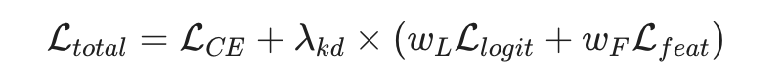

* $λ_{kd}:$ Distillation Factor
* $w_{L }$: Logits Weight
* $w_{F }$: Feature Weight

## 

## 3. Related Work

### 3.1 Transfer Learning with EfficientNet Architecture

Transfer Learning is a technique where a model developed for a task is reused as the starting point for a model on a second task. It is particularly vital in domains where labeled data is scarce or expensive to obtain.

* **Key Studies:**
  + **Tan & Le (2019)** introduced **EfficientNet**, which proposed a "compound scaling" method to uniformly scale network width, depth, and resolution. EfficientNet-B0, utilized in this project, achieves state-of-the-art accuracy while being significantly more computationally efficient than predecessors like ResNet or MobileNet [1].
  + **Kornblith et al. (2019)** investigated the relationship between ImageNet performance and transfer learning. They found that better ImageNet models transfer better across a variety of tasks, justifying the selection of a strong backbone like EfficientNet for butterfly classification [5].

### 3.2. Continual Learning and Catastrophic Forgetting

Continual Learning (or Incremental Learning) aims to enable agents to learn from a continuous stream of data without forgetting previously acquired knowledge. The primary obstacle is "Catastrophic Forgetting," where the network's weights are drastically altered to minimize loss on new data, degrading performance on old tasks.

* **Key Approaches:**
  + **Kirkpatrick et al. (2017)** proposed **Elastic Weight Consolidation (EWC)**, a regularization-based method that constrains important weights for previous tasks from changing too much when learning new tasks [6].
  + **Rebuffi et al. (2017)** introduced **iCaRL (Incremental Classifier and Representation Learning)**. This approach combines a replay buffer (storing a small subset of old exemplars) with a "nearest-mean-of-exemplars" classification strategy, setting a standard for class-incremental learning [7].

### 3.3. Knowledge Distillation in Incremental Learning

Originally designed for model compression by **Hinton et al. (2015)**, Knowledge Distillation (KD) has become a cornerstone strategy in Continual Learning to preserve knowledge.

* **Key Studies:**
  + **Li & Hoiem (2017)** proposed **Learning without Forgetting (LwF)**. This method uses the old model as a "Teacher" to generate soft labels (logits) for the new data. The new model (Student) is trained to match these soft labels, thereby preserving the decision boundaries of the old tasks without needing old data [8].
  + **Hou et al. (2019)** advanced this concept with **Learning a Unified Classifier via Rebalancing**. They emphasized that distilling only the logits is insufficient; preserving the topology of the feature space is equally important. This supports the use of Feature Distillation losses (like cosine similarity or MSE on feature maps) to ensure the Student model maintains the feature extraction capabilities of the Teacher [9].

# 

# CHAPTER III: PROPOSED METHODOLOGY

## 1. System Overview

The system is designed to process data through a sequential two-stage pipeline, ensuring the model establishes a solid knowledge foundation before entering the continual learning process. The specific workflow is as follows:

### 1.1. Phase 1: Base Training via Transfer Learning

The goal of this phase is to develop a high-accuracy **Baseline Model** using the initial dataset (Dataset 1). This process utilizes **Transfer Learning** combined with **Fine-tuning** through the following steps:

1. **Initialization:** Utilize the **EfficientNet-B0** architecture with pre-trained weights from ImageNet. The final Fully Connected layer is removed and replaced with a new Dense layer corresponding to the number of classes in Dataset 1.
2. **Feature Extraction (Frozen Training):** Freeze all feature extraction layers and train only the final Dense layer. This step allows the new classification layer's weights to adapt to the network's features without disrupting the pre-trained weights.
3. **Fine-tuning:** Unfreeze the last 10-20 layers of the EfficientNet-B0 network and perform retraining with a small learning rate. This technique allows the model to refine high-level features specifically for the nuances of the specific dataset.
4. **Outcome:** A Baseline Model is obtained, which serves as the "**Teacher**" for the subsequent phase.

### 1.2. Phase 2: Continual Learning via Knowledge Distillation

Upon the arrival of a new dataset (Dataset 2), the system transitions to a continual learning mode to expand its knowledge base without retraining from scratch.

1. **Data Preparation:** The input data consists of a combination of Dataset 2 and a **Replay Buffer** containing representative samples from Dataset 1.
2. **Teacher-Student Architecture:**
   * **Teacher:** The Baseline Model from Phase 1 (with fully frozen weights).
   * **Student:** A clone of the Baseline Model (partially or fully unfrozen) to facilitate further learning.
3. **Optimization Mechanism:** The system calculates a **Total Loss** derived from three components:
   * **Hard Loss:** Learning from the ground-truth labels of Dataset 2.
   * **Logit Loss:** Learning from the Teacher's output probabilities.
   * **Feature Loss:** Learning from the Teacher's intermediate feature representations.
4. **Outcome:** A final **Continual Model** is produced, capable of accurately classifying species from both Dataset 1 and Dataset 2

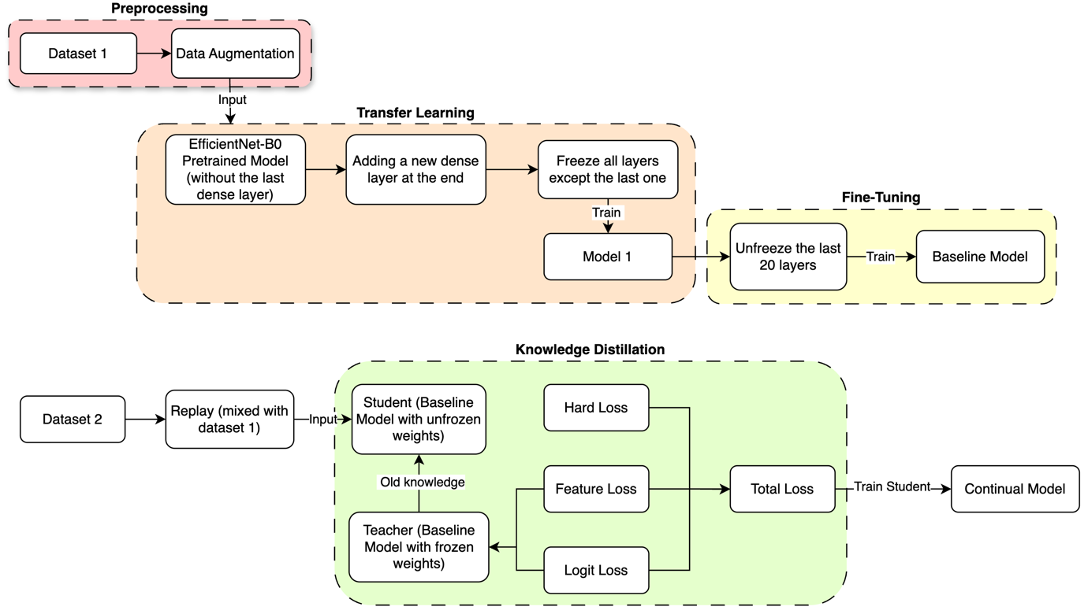

Fig 9: Proposed Training Pipeline with Transfer Learning and Knowledge Distillation

## 2. Dataset

To implement the transfer learning process and evaluate continual learning capabilities, the project utilizes two primary datasets: **Butterfly & Moth Image Classification 100 species (Kaggle)** and **Pollen Grain Classification dataset (VNUA and Dong Van)**

### 2.1. Butterfly & Moth Image Classification 100 species (Kaggle)

The "**Butterfly & Moths Image Classification 100 species (Kaggle)**" (dataset 1) serves as the foundation for the Base Training phase.

* **Scale:** Comprises 100 different species of butterflies and moths.
* **Image Format:** All images are standardized to a resolution of 224 x 224 x 3 pixels in .jpg format.
* **Data Partitioning:**
  + **Training set:** Includes 12,594 images, organized into 100 folders corresponding to each species.
  + **Test set:** Includes 500 images (averaging 5 images per species).
  + **Valid set:** Includes 500 images (averaging 5 images per species).

#### 2.1.1. Butterfly & Moth Image Classification 100 species (self – collected)

The $2^{nd}$ dataset was self-collected to facilitate the Continual Learning phase and verify the model's performance on challenging cases.

* **Characteristics:** This dataset focuses on the same 100 species present in Dataset 1 but captured from different angles and in diverse real-world environments.
* **Collection Strategy:** The project focuses on gathering more images for species with similar morphological characteristics that frequently cause model confusion. This approach helps improve accuracy at complex classification boundaries.
* **Data Partitioning:**
  + **Training set:** Includes 537 images, primarily focused on difficult-to-distinguish species.
  + **Test set:** Includes 499 images (averaging approximately 5 images per species).

#### 2.1.2. Data Specification Summary Table

|  |  |  |
| --- | --- | --- |
|  | Dataset 1 (Butterfly & Moths Image Classification) | Dataset 2 (Self-collected) |
| Number of Species | 100 | 100 |
| Image Resolution | 224 x 224 x 3 | 224 x 224 x 3 |
| Format | jpg | jpg |
| Training Set size | 12,594 images | 537 images |
| Validation Set size | 500 images | - |
| Test Set size | 500 images | 499 images |
| Goal | To train Baseline Model (Transfer Learning) | To train Continual Model (Knowledge Distillation) |

#### 2.1.3. Data Preprocessing

Before being fed into the model, image data goes through the following steps to ensure consistency and enhance generalization capabilities:

* **Resizing:** All input images are resized to 224 x 224 pixels to match the standard input of EfficientNet-B0.
* **Normalization:** Pixel values are scaled to the range [0, 1] and normalized according to ImageNet (mean, std), which helps the model converge faster.
* **Data Augmentation:** Random techniques such as rotation, flipping, and brightness adjustment (RandomBrightness) are applied. This helps the Student model learn invariant features and minimizes overfitting on the sample dataset, which typically has a limited quantity.

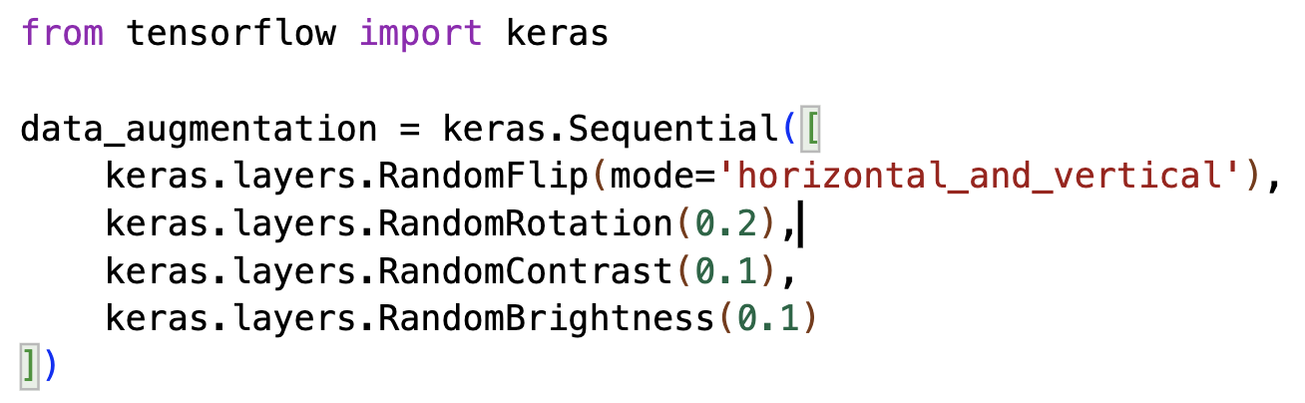

Fig 10: Data Preprocessing code

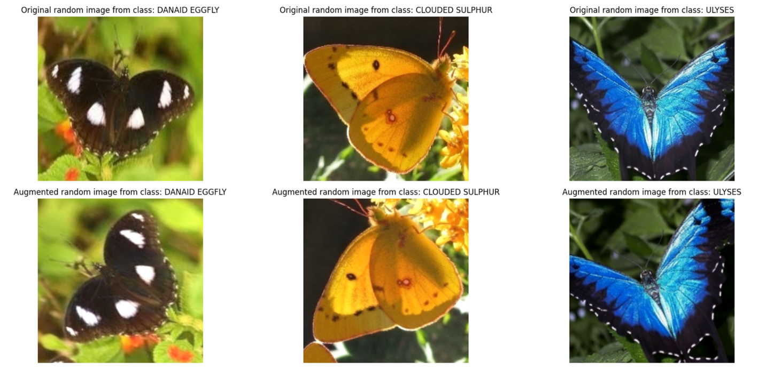

Fig 11: Images before and after data preprocessing

#### 2.1.4. Phase 1: Building the Baseline Model (Transfer Learning)

The implementation process consists of two small steps to achieve optimal performance:

**Transfer Learning with EfficientNet-B0**

* **Initialization:** Use the EfficientNet-B0 backbone pre-trained on ImageNet and remove the old classification layer.
* **Add new layers:** Add a new Dense layer suitable for the number of classes to be classified and add a Global Average Pooling layer to compress data for dimension matching and prevent from overfitting
* **Freezing:** Freeze all pre-trained layers, only allowing weight updates in the newly added Dense layer to protect the base features.
* **Training:** Perform model training on dataset 1.

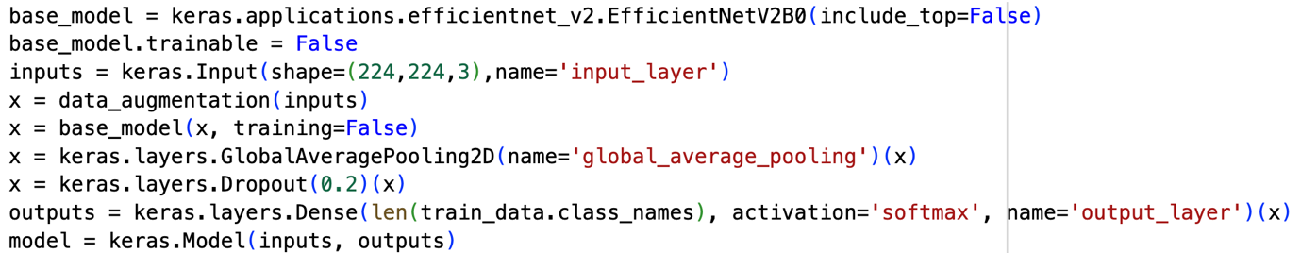

Fig 12: Transfer Learning with EfficientNet-B0 code

**Fine-Tuning**

* **Unfreeze:** Proceed to unfreeze the last 20 layers of the network (helping the model adapt more deeply to the specific morphological characteristics of butterfly species while maintaining stability).
* **Training:** Continue training the model on dataset 1 with a small learning rate (1e-5 to 1e-4).
* **Result:** Obtain the **Baseline Model** to serve as the foundation for the continuous learning phase.

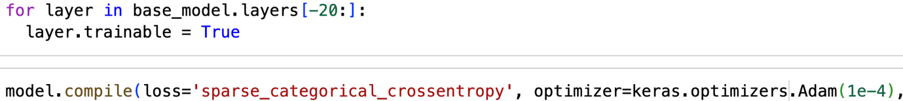

Fig 13: Fine-tuning code

#### 2.1.5. Phase 2: Continual Learning with Knowledge Distillation

This stage helps the model integrate data from **Dataset 2** without forgetting the knowledge acquired from **Dataset 1**.

**Teacher - Student Setup**

* **Teacher Model:** Uses the Baseline Model with fully frozen weights to serve as the reference for old knowledge.
* **Student Model:** Initialized from the Baseline Model but allows weight updates to learn new knowledge.

**Replay Strategy**

The training data is a mixture of **Dataset 2** and samples from **Dataset 1** to create a balance of knowledge.

**Loss Functions**

The Student model is optimized through a combination of 3 component losses and 1 total loss:

* **Hard Loss:** The Cross-entropy error between the Student's predictions and the ground truth labels of Dataset 2.
* **Logit Loss:** Uses KL Divergence to force the Student's output probability distribution to match the Teacher's, preserving old classification boundaries.
* **Feature Loss:** Compares the similarity between feature vectors at the Global Average Pooling layer of both models to maintain morphological feature extraction.
* **Total Loss:** Balances the acquisition of new data and the preservation of old knowledge.

**Logits Distillation Class**

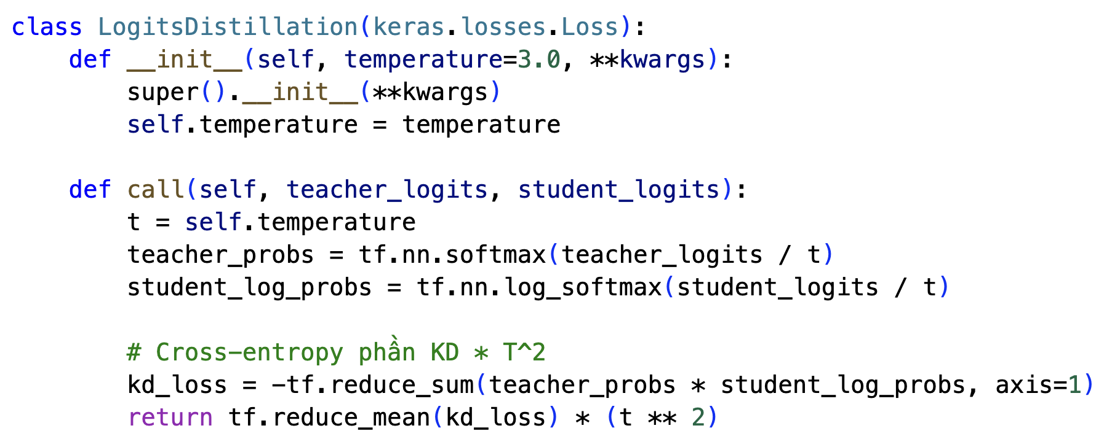

Fig 14: The Logits Distillation Class

The **LogitsDistillation class** is implemented to calculate the discrepancy between the knowledge of the Teacher and Student models through the following steps:

* **Temperature Scaling**: Utilizes the temperature parameter (default $T$ = 3.0) to scale the Logits values of both the Teacher and Student models. This process "softens" the probabilities, allowing the model to capture latent relationships or "dark knowledge" between data classes.
* **Probability Calculation**:
  + **Teacher**: Applies the *softmax function* to generate soft targets.
  + **Student**: Applies the *log_softmax function* to prepare for log-likelihood estimation.
* **Objective Function (Cross-Entropy)**: Computes the cross-entropy between the Teacher's probabilities and the Student's log-probabilities using *-tf.reduce_sum*to quantify the divergence between the two models.
* **Gradient Normalization ($T^2$)**: The final result logits loss is multiplied by $T^2.$ This step compensates for the reduction in gradient magnitude caused by the initial division by $T$, ensuring the learning signal remains strong and properly balanced with other loss functions in the system.

**Feature Distillation Class**

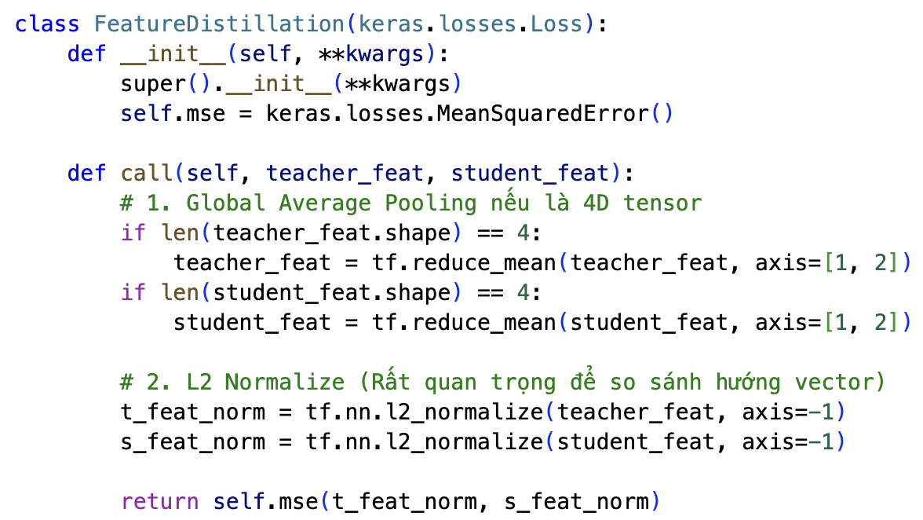

Fig 15: The Feature Distillation Class

The **FeatureDistillation class** is implemented to ensure that the intermediate feature representations extracted by the Student model align with those of the Teacher model through the following steps:

* **Global Average Pooling (GAP):** If the input features are 4D tensors, the class applies *tf.reduce_mean* across the spatial dimensions (axis 1 and 2). This reduces the spatial dimensions to a single global vector, making the loss invariant to slight spatial translations or shifts in the input images.
* **L2 Normalization:** Both the Teacher and Student feature vectors are normalized using *tf.nn.l2_normalize* along the last axis. This step is critical as it allows the model to compare the **direction** of the feature vectors (semantic orientation) rather than their absolute magnitudes.
* **Final Output (Mean Squared Error):** The class utilizes the *MeanSquaredError()* objective to measure the Euclidean distance between the normalized feature vectors of the two models. This resulting scalar value acts as a structural constraint, forcing the Student’s backbone to maintain a visual understanding similar to the Teacher's, thereby effectively preventing catastrophic forgetting at the feature level.

**Total Loss**

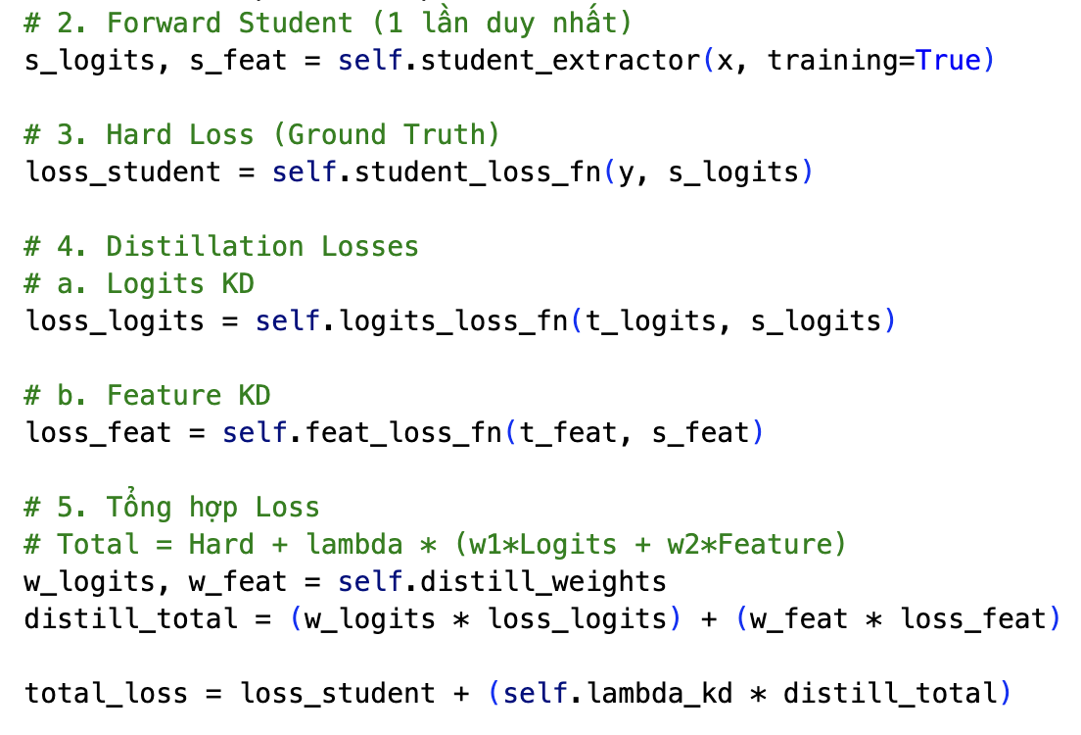

Fig 16: Total Loss computation code

The **Total Loss** is calculated as follows:

* **Hard Loss ($loss_{student}$**): Standard Cross-entropy between Student predictions and ground-truth labels from the new dataset.
* **Distillation Losses:**
  + **Logit Loss ($loss_{logits}$**):Ensures Student output probabilities match the Teacher's classification boundaries.
  + **Feature Loss ($loss_{feat}$**): forces the Student to have a perspective and feature extraction method similar to the Teacher through intermediate layers.
* **Combined Distillation Loss: $distill_{total}=\left(w_{logits}*loss_{logits}\right) +(w_{feat }+loss_{feat}$** )
* **Final Objective Function: $total_{loss}=loss_{student} +(lamda_{kd}+distill_{total}$** )

**Hyperparameter configuration**

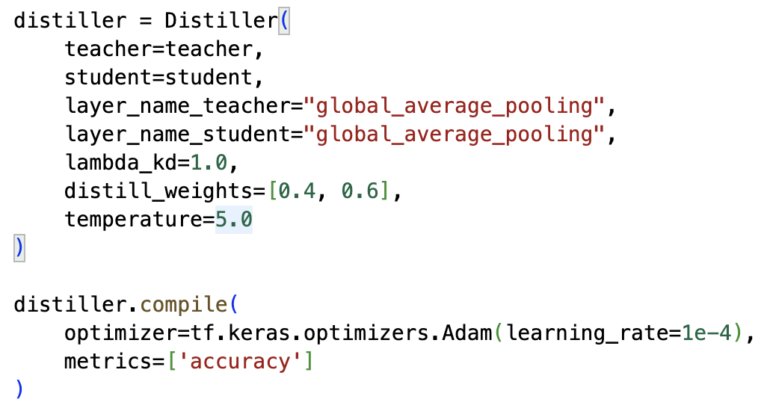

Fig 17: Hyperparameter configuration for Butterfly dataset

The configuration of **the Distiller hyperparameters** is crucial for balancing the acquisition of new knowledge with the preservation of previously learned information. The primary parameters are selected as follows:

* **Extracted Layer ($global_average_pooling$):** Both the Teacher and Student models extract features at the global_average_pooling layer. Selecting this layer allows for the comparison of morphological features at the most generalized level, ensuring spatial invariance during **Feature Loss** computation.
* **Regulation Factor ($lambda_kd = 1.0$):** This coefficient determines the relative importance of the total distillation loss compared to the direct learning error (Hard Loss). With a value of 1.0, the system treats the guidance signal from the Teacher with equal importance to the ground-truth labels from Dataset 2, effectively preventing catastrophic forgetting.
* **Distillation Weights ($distill_weights = [0.4, 0.6]):$** These weights prioritize the specific components of the distillation loss:
  + $w_{logits}= 0.4$**:** Allocated to Logit Loss to focus on preserving established classification boundaries.
  + $w_{feat }=0.6$**:** Given higher priority to Feature Loss, forcing the Student to strictly maintain the core feature extraction capabilities of the Teacher.
* **Temperature ($T=5.0$):** The temperature parameter is set to a high value ( $T=5.0)$ to maximize the "softening" of probability distributions. This enables the Student to capture subtle inter-class relationships ("dark knowledge") from the Teacher, rather than focusing solely on the most probable class.
* **Optimization:** The **Adam** optimizer is utilized with a low learning rate ($learning_rate = 1e-4$) to ensure stable convergence and avoid disrupting the weights optimized in the previous stage.

### 2.2. Pollen Grain Classification dataset (VNUA and Dong Van)

The "**Pollen Grain Classification dataset (VNUA)**" serves as the foundation for the Base Training phase.

* **Scale:** Comprises 52 different species of Pollen Grain.
* **Image Format:** All images are standardized to a resolution of 224 x 224 x 3 pixels.
* **Data Partitioning:** 
  + **Training set:** Includes 7118 images, organized into 52 folders corresponding to each species.
  + **Test set:** Includes 1807 images, organized into 52 folders corresponding to each species.

The "**Pollen Grain Classification dataset (Dong Van)**" will be used in the Continual Learning phase and verify the model's performance on challenging cases.

* **Characteristics:** This dataset contains new 20 species and 2 old species from the previous dataset.

**Data Partitioning for Continual Learning:** To facilitate sequential learning, this dataset is divided into two distinct tasks:

* **Task 1 (Continual learning on 2 old species from the Baseline Model):**
  + **Training set:** Includes 40 images, organized into folders for the 2 existing species.
  + **Test set:** Includes 163 images, organized into folders for the 2 existing species (split ratio ~1:4).
* **Task 2 (Continual learning on 20 new species from Task 1 model):**
  + **Training set:** Includes 400 images, organized into folders for the 20 new species.
  + **Test set:** Includes 1634 images, organized into folders for the 20 new species (split ratio ~1:4).

#### 2.2.1. Hyperparameter setup for Continual Learning

Inheriting the system architecture developed for the Butterfly classification task, we conducted parallel experiments on the Pollen Grain dataset. Due to the similarities in image structures and task requirements, we omit the detailed technical descriptions of the methodologies—such as Data Augmentation, Logits Distillation, and Feature Distillation—which remain consistent with the previous section. Instead, this section focuses on the specific configuration parameters and the experimental results achieved on this particular dataset.

**Task 1 (Continually learning on 2 old species):**

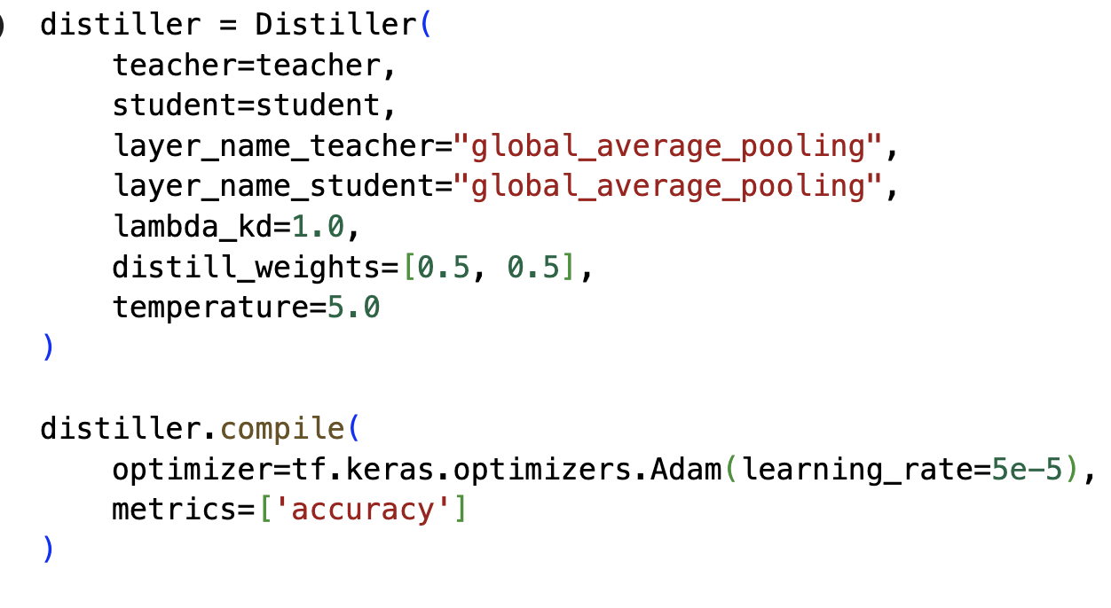

Fig 18: Task 1 Hyperparameter Configuration for the Pollen Grain Dataset

* **Extracted Layer ($global_average_pooling$):** Feature extraction is performed at the global_average_pooling layer for both the Teacher and Student models. This selection facilitates a comparison of global morphological characteristics, ensuring that the **Feature Loss** remains spatially invariant regarding the complex structures of pollen grains.
* **Regulation Factor ($lambda_kd = 1.0$):** This factor is set to 1.0 to establish an absolute balance between the direct learning error (Hard Loss) and the guidance signal from the Teacher model (Distillation Loss). This ensures the Student acquires new information under rigorous supervision to prevent the loss of established patterns.
* **Distillation Weights ($w_{logits}= 0.5, w_{feat }=0.5$):** Weights are distributed equally between the two distillation components. This configuration forces the model to place equal emphasis on mimicking classification boundaries (Logit Loss) and synchronizing intermediate feature spaces (Feature Loss), which is essential for datasets with high morphological variance like pollen.
* **Temperature ($T = 5.0$):** A high temperature value is utilized to soften the output probability distributions. This mechanism allows the Student to capture subtle "dark knowledge" regarding inter-class relationships, leading to a more flexible and comprehensive learning process.
* **Optimization:** The **Adam** optimizer is employed with a precise learning rate of $5e-5$. This rate is calculated to ensure stable convergence, allowing the model to refine weights delicately without causing significant disruptions to the already defined feature space.

**Task 2 (Continually learning on 20 new species):**

To continue learning 20 additional species, the hyperparameters were adjusted 3 times. Each time will be trained for 5 epochs with 52 steps per epoch to achieve the optimal results.

**Iteration 1** focuses on rapidly adapting the model to new data while maintaining high supervisory pressure from the Teacher model:

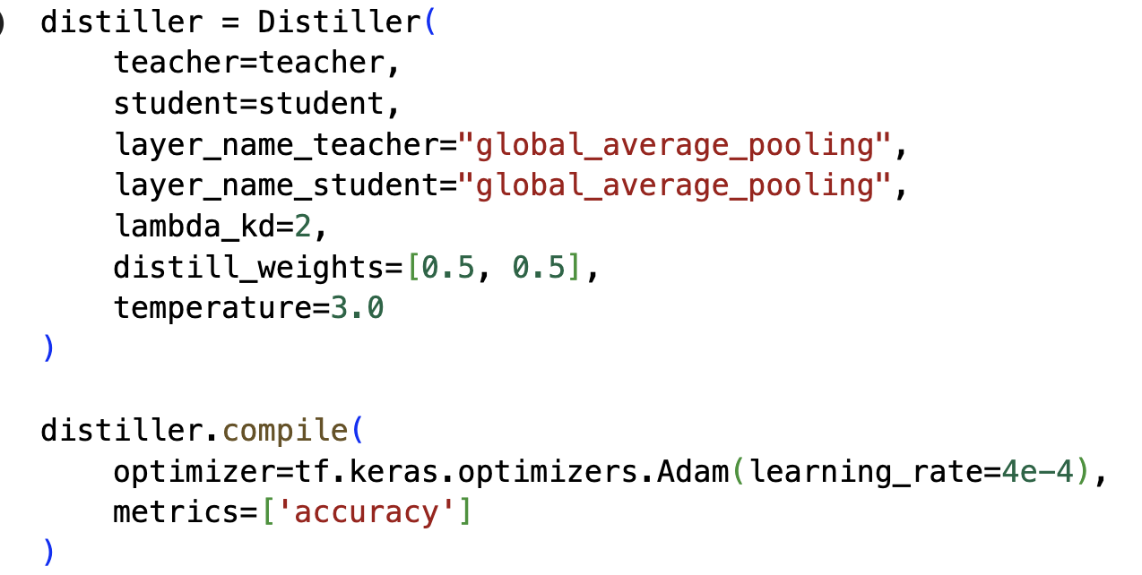

Fig 19: Hyperparameter Configuration for iteration 1

* **Regulation Factor ($lambda_kd = 2.0$):** This value prioritizes the preservation of established patterns by giving the distillation signal twice the importance of the direct learning loss.
* **Distillation Weights ($w_{logits}= 0.5, w_{feat }=0.5$):** An equal balance is maintained between mimicking classification logic and internal feature representations.
* **Temperature ($T = 3.0$):** A moderate temperature is applied to "soften" probability distributions, facilitating the transfer of latent class relationships.
* **Optimization ($learning_rate = 4e-4$)** A higher learning rate is utilized for swift initial adaptation to the 20 new species.

In the $2^{nd}$**iteration**, the configuration is adjusted to emphasize decision logic and enhance the depth of knowledge transfer:

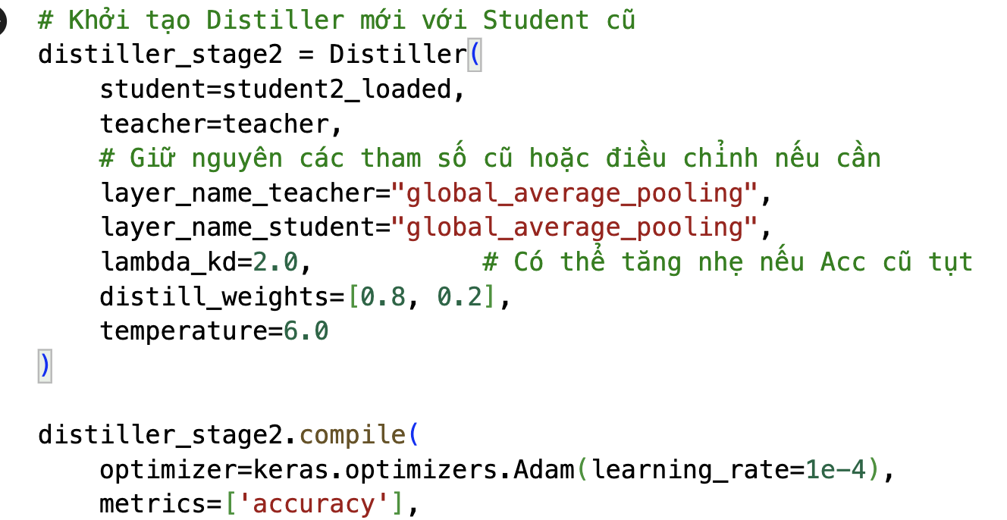

Fig 20: Hyperparameter Configuration for iteration 2

* **Regulation Factor ($lambda_kd = 2.0$):** The system maintains high regulation to safeguard against catastrophic forgetting as classes expand.
* **Distillation Weights ($w_{logits}= 0.8, w_{feat }=0.2$):** Focus shifts heavily toward the Logit Loss (80%) to strictly align the Student's classification boundaries with the Teacher's logic, helps improving accuracy on the old dataset.
* **Temperature ($T = 6.0$):** A high temperature is used to maximize the extraction of "dark knowledge", smoothing the distributions to highlight subtle class similarities.
* **Optimization ($learning_rate = 1e-4):$**The learning rate is reduced to provide careful weight updates and consistent convergence.

The **final iteration** adjusts the balance to allow the model to fully integrate new ground-truth patterns while maintaining the logic established in previous stages:

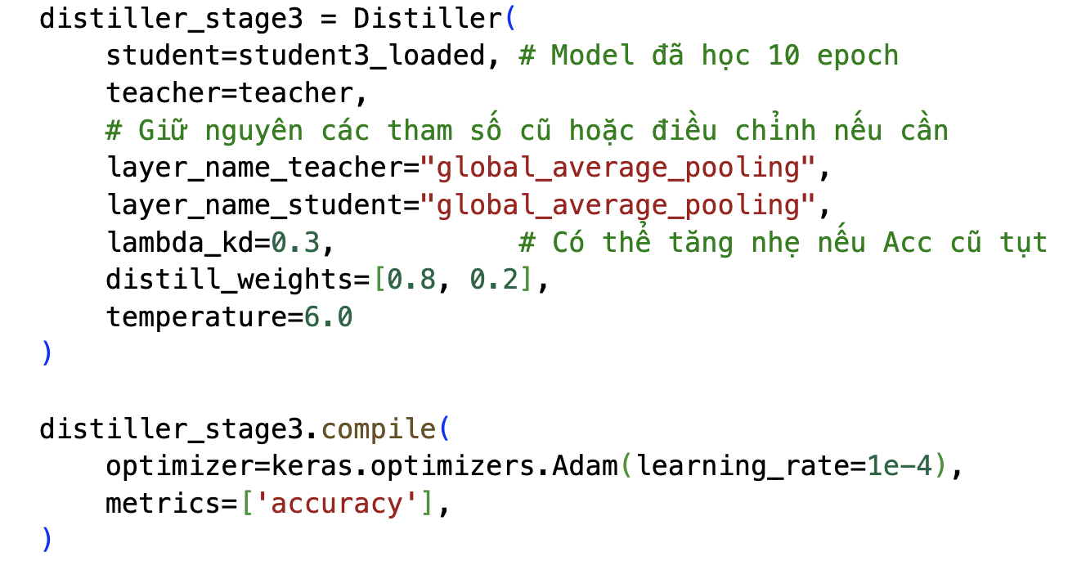

Fig 21: Hyperparameter Configuration for iteration 3

* **Regulation Factor ($lambda_{kd}= 0.3$):** This factor is set to a lower value, allowing the model to focus more on the Hard Loss from the new dataset labels, helps improving accuracy on the new dataset.
* **Distillation Weights ($w_{logits}= 0.8, w_{feat }=0.2$):** The model continues to prioritize classification logic to ensure the decision boundaries remain sharp.
* **Temperature ($T = 6.0$):** High temperature is maintained to keep probability distributions soft during the final optimization phase.
* **Optimization ($learning_rate = 1e-4):$**The learning rate is kept to ensure that final adjustments to the weights are stable and do not cause performance spikes.

# CHAPTER IV: EXPERIMENT RESULTS AND ANALYSIS

## 1. Experimental Setup

* **Hardware:** T4 GPU on Google Colab.
* **Software:** Python, TensorFlow/Keras, Matplotlib, Streamlit.

## 2. Case Study I: Butterfly & Moth Image Classification 100 species

### 2.1 Transfer Learning Results

**Model 1** has achieved **97.2% accuracy** on test set of **Dataset 1** (Butterfly & Moth Image Classification 100 species (Kaggle)).



Fig 22: Model 1 accuracy on Dataset 1 (Butterfly)

Below is the learning curve diagram:

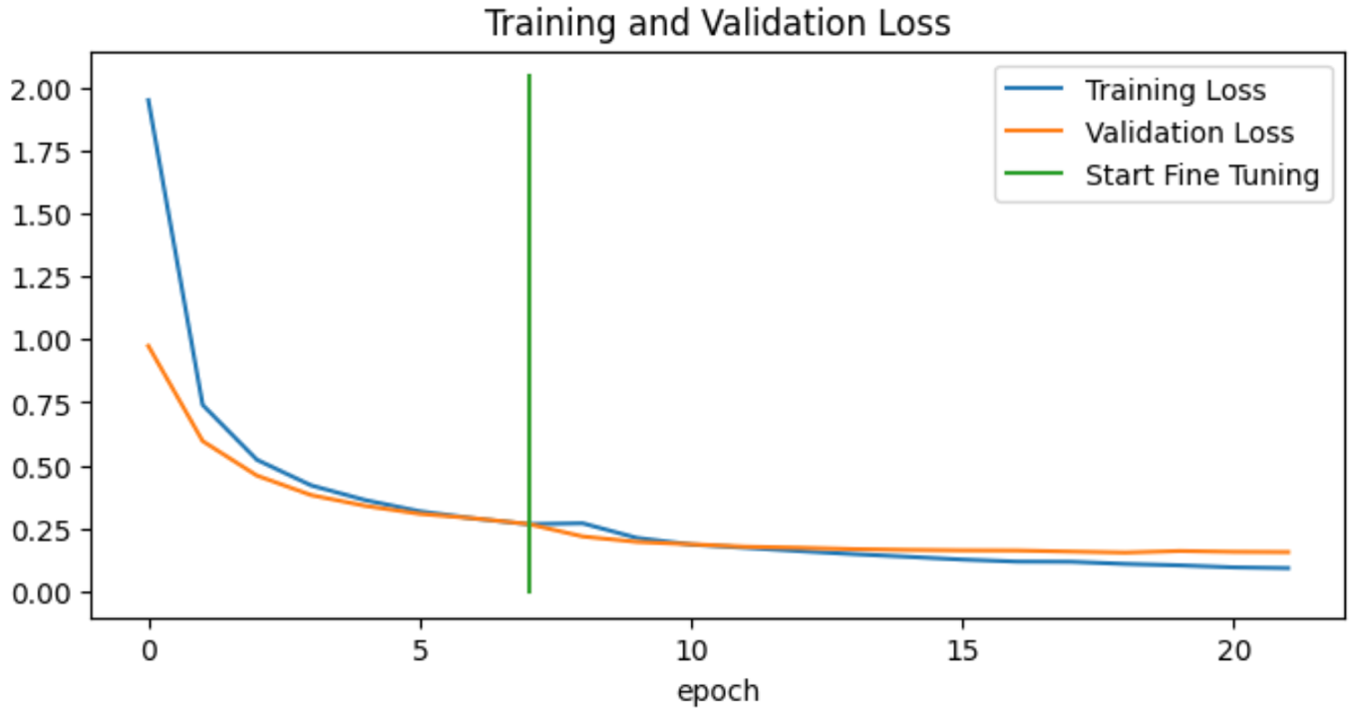

Fig 23: Loss Chart of Butterfly dataset

**Loss Chart (Training and Validation Loss):** The loss functions for both the training and validation sets decreased sharply during the first 5 epochs and maintained a steady downward trend upon entering the fine-tuning stage. The close convergence between the two loss curves indicates that the model does not exhibit overfitting.

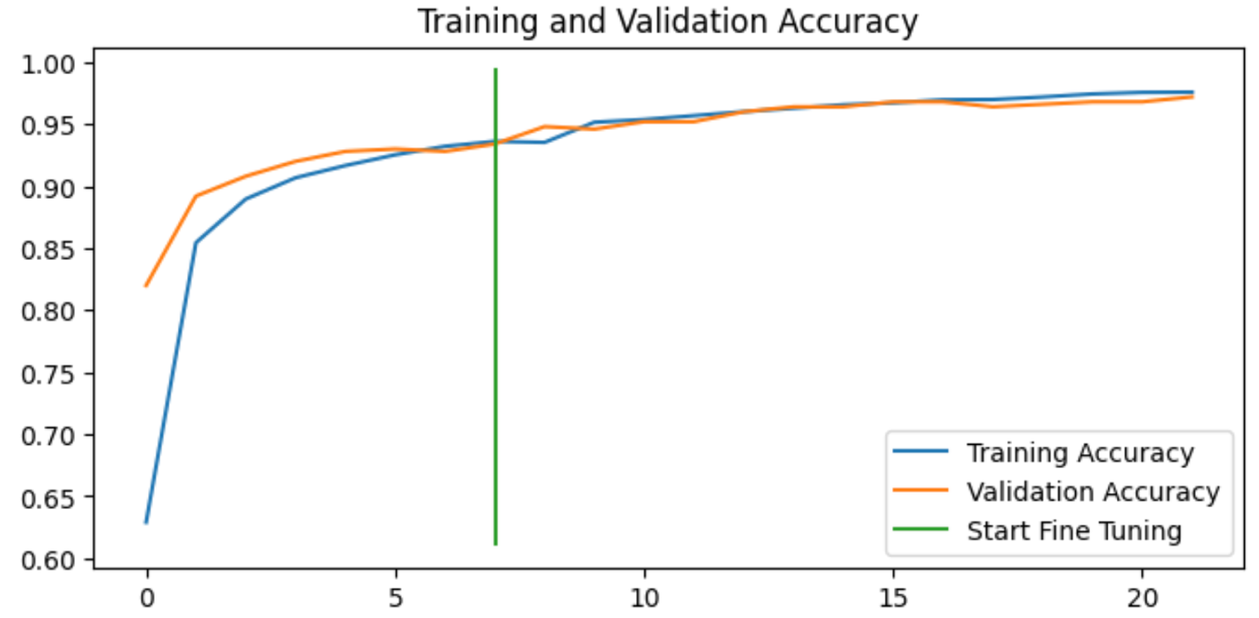

Fig 24: Accuracy Chart of Butterfly dataset

**Accuracy Chart (Training and Validation Accuracy):** The accuracy surged after just the first 5 epochs. Following the commencement of the fine-tuning process, the accuracy continued to improve, stabilizing and converging at approximately **97%** on both datasets.

Here is some species that has lower F1-score:

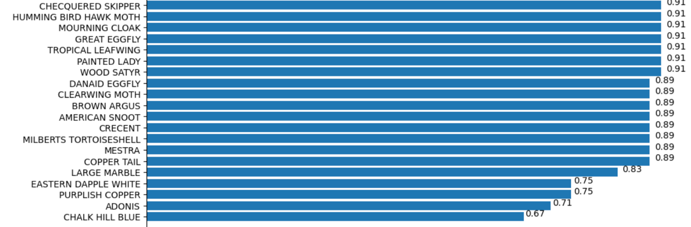

Fig 25: F1-score Chart

**Based on the confusion matrix (as shown in the source code),** species with lower F1-scores are those that share similar morphological characteristics with others—such as patterns, coloration, and petal shapes—which easily leads to misclassification by the model.

|  |  |  |
| --- | --- | --- |
| **Name** | **F1-score** | **Most confused with** |
| Chalk Hill Blue | 0.67 | Adonis |
| Eastern Dapple White | 0.75 | Large Marble |
| Pulish Copper | 0.75 | Chalk Hill Blue, Adonis |

Fig 26: Lowest F1-score species Table

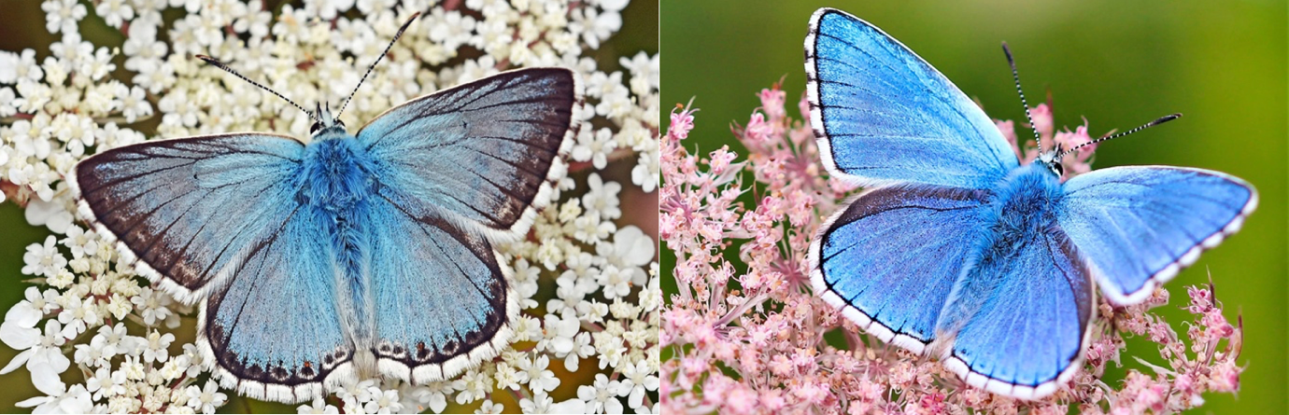

Fig 27: Chalk Hill Blue and Adonis

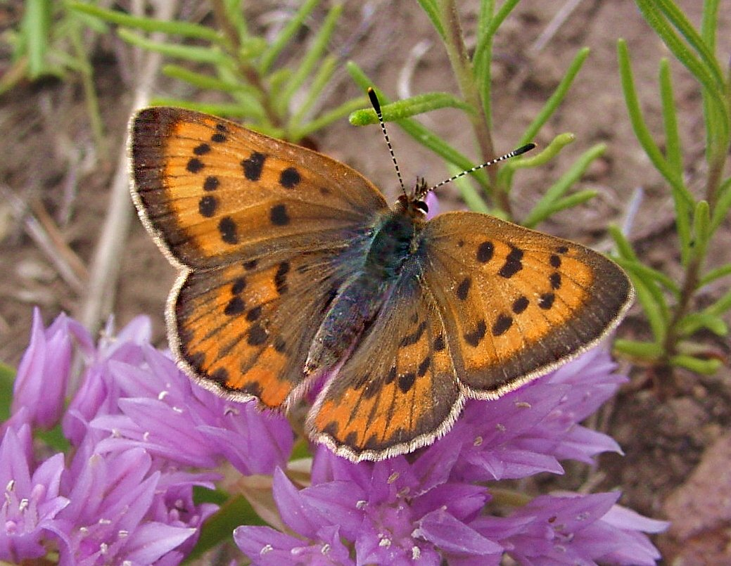

Fig 28: Purlish Copper

### 2.2 Continual Learning Results

First, we evaluated the accuracy of **Model 1** on the test set of **Dataset 2** (Butterfly & Moth Image Classification, 100 species, self-collected), which the model had not previously encountered. The resulting accuracy is **90.8%,** which remains relatively high despite the new data. This suggests that Dataset 2 does not differ significantly from Dataset 1, indicating a low domain shift.



Fig 29: Model 1 accuracy on Dataset 2 (Butterfly)

However, it is expected that continual learning can improve this accuracy.

As expected, the accuracy of **Model 2** (further trained from Model 1) on **Dataset 2** improved compared to Model 1 (from **90.8%** to **93.4%).** Notably, the accuracy on the original dataset (Dataset 1) remained nearly unchanged (**96.8%** compared to **97.2%).** This demonstrates that the model successfully acquired new knowledge while avoiding catastrophic forgetting of previous information.

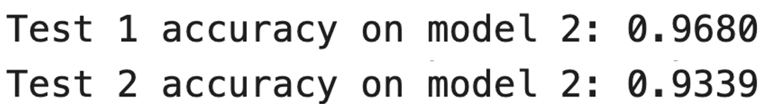

Fig 30: Model 2 accuracy on Dataset 1 & 2

### 2.3 Model F1-Scores on Dataset 2

|  |  |  |
| --- | --- | --- |
| **Butterfly Species** | **Model 1** | **Model 2** |
| AFRICANT GIANT SWALLOWTAIL | 1.0 | 0.89 |
| ATLAS MOTH | 0.73 | 0.91 |
| BECKERS WHITE | 1.0 | 0.89 |
| BIRD CHERRY ERMINE MOTH | 0.91 | 1.0 |
| BLACK HAIRSTREAK | 0.89 | 1.0 |
| BLUE MORPHO | 0.57 | 0.89 |
| CHALK HILL BLUE | 0.77 | 0.83 |
| CHECQUERED SKIPPER | 0.57 | 0.8 |
| CHESTNUT | 0.91 | 1.0 |
| CINNABAR MOTH | 0.75 | 0.89 |
| CLEARWING MOTH | 0.57 | 0.89 |
| COPPER TAIL | 0.67 | 0.89 |
| DANAID EGGFLY | 0.89 | 0.8 |
| EASTERN COMA | 0.73 | 0.8 |
| EASTERN DAPPLE WHITE | 0.62 | 0.57 |
| GIANT LEOPARD MOTH | 0.89 | 1.0 |
| GREEN HAIRSTREAK | 0.91 | 1.0 |
| HERCULES MOTH | 0.67 | 0.89 |
| HUMMING BIRD HAWK MOTH | 0.77 | 0.91 |
| Iphiclus sister | 0.91 | 1.0 |
| LARGE MARBLE | 0.57 | 0.6 |
| PAPER KITE | 0.91 | 1.0 |
| PURPLISH COPPER | 0.83 | 0.91 |
| QUESTION MARK | 0.67 | 0.8 |
| SILVER SPOT SKIPPER | 0.75 | 0.89 |
| SIXSPOT BURNET MOTH | 0.83 | 0.91 |
| ULYSES | 0.83 | 0.91 |
| YELLOW SWALLOW TAIL | 0.75 | 0.89 |

Fig 31: Model F1-Scores on Dataset 2 Table

Observations show that among the 28 species with shifting F1-scores, 24 species saw an increase, indicating that the model's overall classification performance has been significantly enhanced.

### 2.4. Metrics Comparision Table

|  |  |  |  |  |  |  |  |  |
| --- | --- | --- | --- | --- | --- | --- | --- | --- |
| **Dataset** | **Model** | **Accuracy** | **Macro avg** | | | **Weighted avg** | | |
| **Precision** | **Recall** | **F1-score** | **Precision** | **Recall** | **F1-score** |
| Dataset 1 | Model 1 | 97.2% | 98% | 97% | 97% | 98% | 97% | 97% |
| Model 2 | 96.8% | 97% | 97% | 97% | 97% | 97% | 97% |
| Dataset 2 | Model 1 | 90.8% | 93% | 91% | 90% | 93% | 91% | 90% |
| Model 2 | 93.4% | 95% | 93% | 93% | 95% | 93% | 93% |

Fig 32: Metrics Comparision Table (Butterfly Dataset)

|  |  |  |
| --- | --- | --- |
|  | **Model 1** | **Model 2** |
| Training time | 14m08s | 1m44s |

Fig 33: Model’s training time (Butterfly Dataset)

## 3. Case Study II: Pollen Grain Classification

### 3.1. Transfer Learning Results

**Model 1** has achieved **94.2%** accuracy on **Dataset 1** (Pollen Grain Classification dataset (VNUA)).



Fig 34: Model 1 accuracy on Dataset 1 (Pollen Grain)

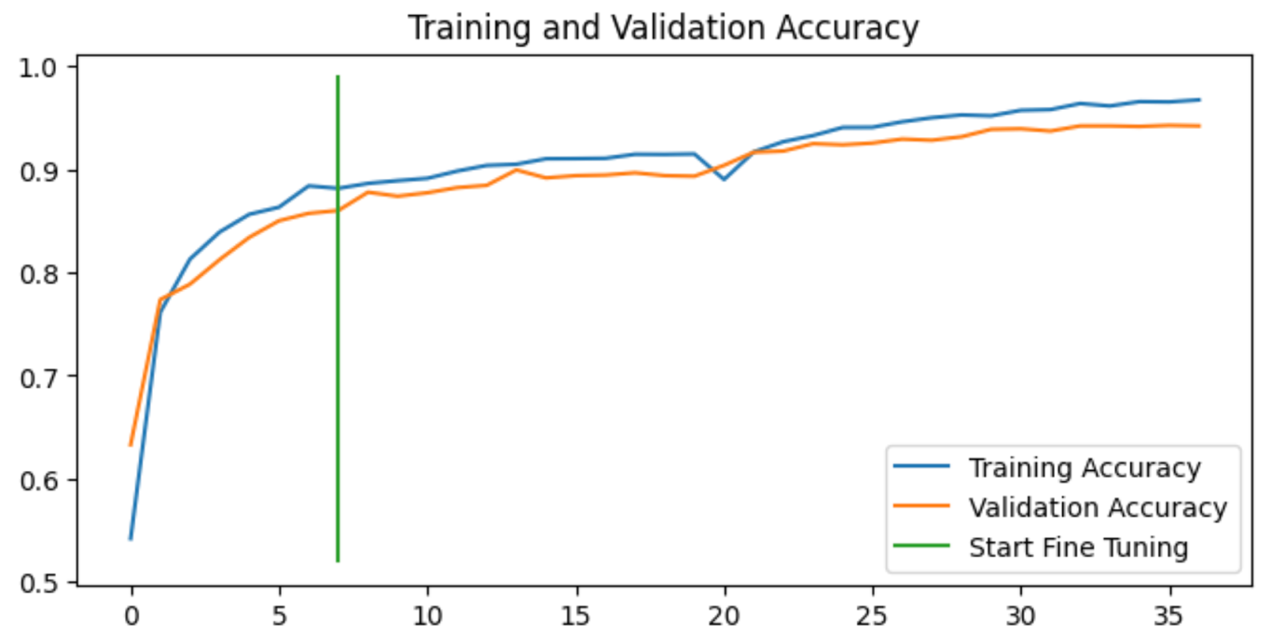

Fig 35: Accuracy Chart of Pollen Grain dataset

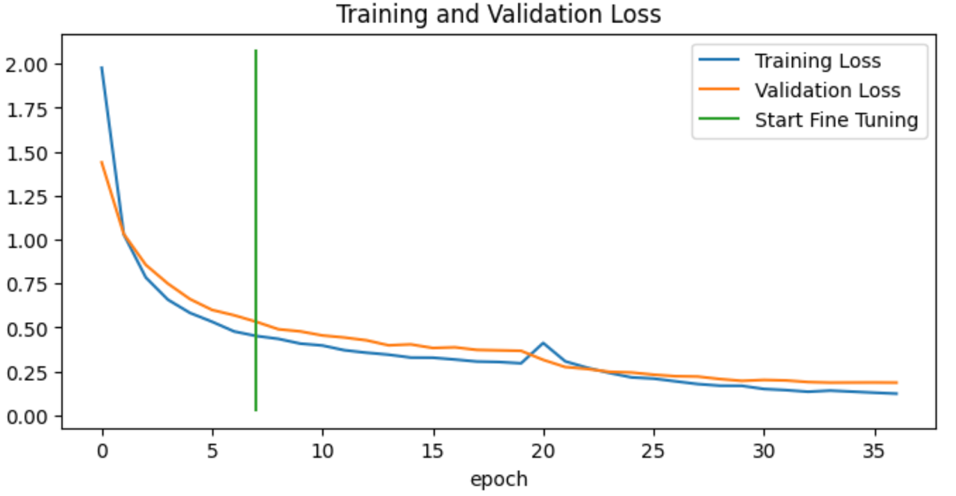

Fig 36: Loss Chart of Pollen Grain dataset

### 3.2 Continual Learning Results

#### 3.2.1 Model 2

**Model 2** is the model that continued to learn from **Model 1** using Dataset 2, which is a sub-dataset of the Pollen Grain Classification dataset (Dong Van). It consists of two existing species but exhibits a significant **domain shift**.

First, we evaluate the accuracy of Model 1 on the test set of this new dataset (Dataset 2). The accuracy reached only **33%,** proving that even for known species, model performance can degrade significantly when the domain shift is large.



Fig 37: Model 1 accuracy on Dataset 2 (Pollen Grain)

In this scenario, applying **Continual Learning** is expected to substantially improve the model's performance.

As anticipated, Model 2 showed substantial improvement, reaching an accuracy of **95.7%.**



Fig 38: Model 2 accuracy on Dataset 2 (Pollen Grain)

The accuracy on the original dataset (Dataset 1) remained high at 93% (compared to the initial 94.2%), further confirming that the model did not suffer from catastrophic forgetting.



Fig 39: Model 2 accuracy on Dataset 1 (Pollen Grain)

#### 3.2.2 Model 3

**Model 3** is a model that continues training from **Model 2** using **Dataset 3**, which is a sub-dataset of the Pollen Grain Classification dataset (Dong Van) consisting of 20 novel species.

Model 3 achieves **87.15%** accuracy on the new dataset (Dataset 3) and **92.4%** accuracy on the previous dataset (Dataset 1).

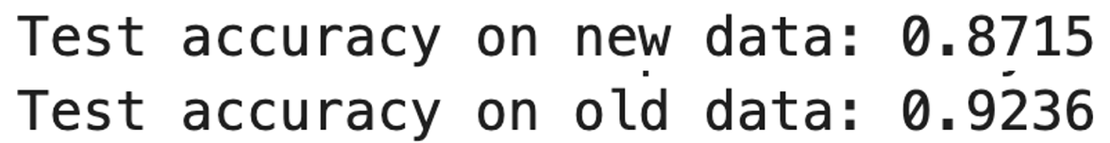

Fig 40: Model 3 accuracy on Dataset 3 & 1 (Pollen Grain)

These results demonstrate the effectiveness of Continual Learning in general, and Knowledge Distillation in particular, as accuracy on the new dataset continues to increase while performance on the old dataset remains nearly stable.

### 3.3 Metrics Comparision Table

|  |  |  |  |  |  |  |  |  |
| --- | --- | --- | --- | --- | --- | --- | --- | --- |
| **Dataset** | **Model** | **Accuracy** | **Macro avg** | | | **Weighted avg** | | |
| **Precision** | **Recall** | **F1-score** | **Precision** | **Recall** | **F1-score** |
| Dataset 1 | Model 1 | 94.2% | 93% | 92% | 92% | 94% | 94% | 94% |
| Model 2 | 93.03% | 93% | 90% | 90% | 93% | 93% | 93% |
| Model 3 | 92.4% | 90% | 89% | 89% | 92% | 92% | 92% |
| Dataset 2 | Model 1 | 33.1% | 58% | 33% | 42% | 59% | 33% | 42% |
| Model 2 | 95.7% | 97% | 96% | 97% | 98% | 96% | 97% |
| Dataset 3 | Model 3 | 87.15% | 91% | 86% | 88% | 90% | 87% | 88% |

Fig 41: Metrics Comparision Table (Pollen Grain Dataset)

|  |  |  |  |
| --- | --- | --- | --- |
|  | **Model 1** | **Model 2** | **Model 3** |
| Training time | 14m50s | 2m07s | 6m33s |

Fig 42: Model’s training time (Pollen Grain Dataset)

# 

# CHAPTER V: DEPLOYMENT

## 1. Introduction

The objective of this chapter is to develop a visual **User Interface (UI)** that allows end-users to interact with the model without source code intervention.

* **Usability:** Transitioning the model from the training environment to a real-world application.
* **Interactivity:** Enabling users to upload images of pollen grains or butterflies and receive instantaneous prediction results.

## 2. Technology Stack

To build the application, we selected **Streamlit**, an open-source Python framework designed specifically for Machine Learning and Data Science projects.

**Rationale for using Streamlit:**

* **Rapid Prototyping:** Streamlit allows for the quick transformation of Python scripts into interactive web applications without the need for complex backend development (e.g., HTML, CSS, JavaScript).
* **Seamless Integration:** It integrates natively with **TensorFlow/Keras**, enabling the efficient loading of the complex model weights.
* **Visualization Capabilities:** It provides built-in tools for displaying images, probability charts, and data tables, which are essential for interpreting classification results.

## 3. System Architecture

The deployment architecture follows a standard client-server model optimized for inference tasks.

1. **Input Layer:** The user interacts with the web interface to upload an image (supported formats: JPG, PNG, JPEG).
2. **Preprocessing:** Images are preprocessed (resized, normalized) to match the model's input requirements.
3. **Inference:** The trained model (**Student Model**) performs predictions based on acquired knowledge.
4. **Output:** Displays the predicted species name and the **Confidence Score**.

## 4. Main Features of the Application

**Key Features of the Application**

* **Image Upload Feature**: Supports formats including .jpg, .png, and .jpeg.
* **Real-time Classification**: Returns results within seconds thanks to the optimized model architecture.
* **Visual Display**: Utilizes charts to illustrate the prediction probabilities of the top 3 most likely species.

## 5. Demo

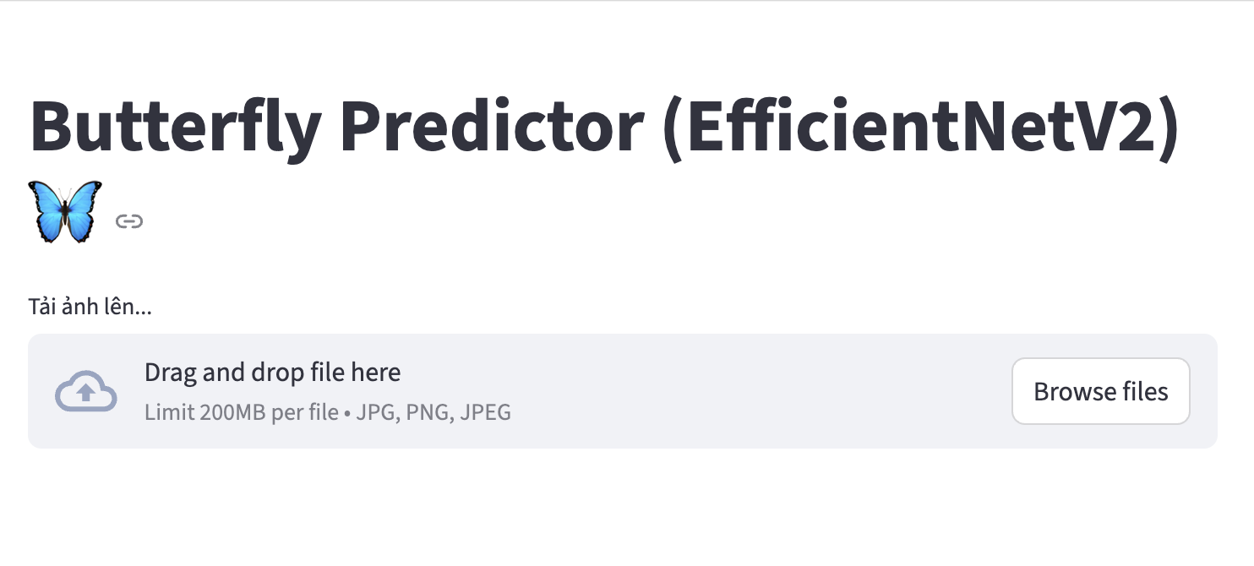

Fig 43: User Interface of the Butterfly Species Prediction Application

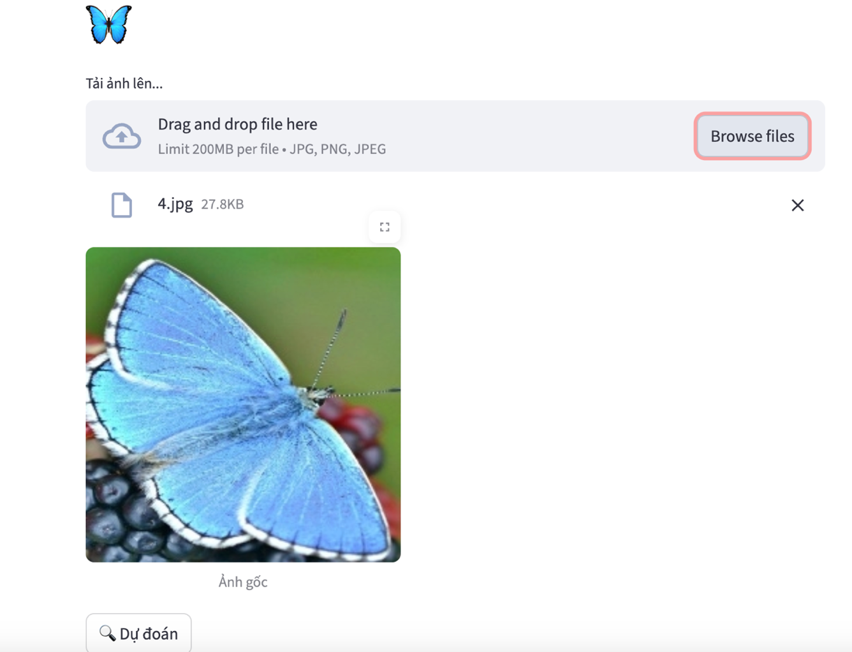

Fig 44: Input Interface for Image Uploading and Pre-processing

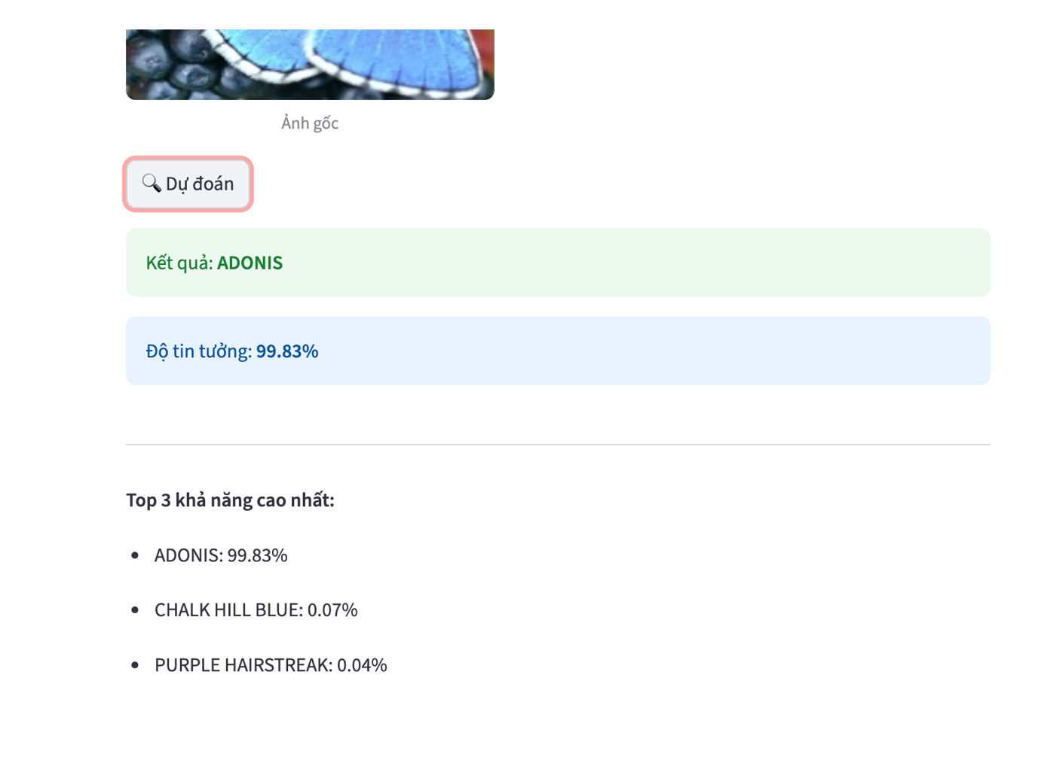

Fig 45: Classification Results Displaying Species Name and Confidence Score.

# 

# CHAPTER VI: CONCLUSION AND FUTURE WORK

## 1. Conclusion

The research has successfully developed and evaluated two high-performance, independent classification models for **Butterfly** and **Pollen Grain** datasets. By combining modern deep learning architectures with advanced training strategies, the project achieved its primary objectives. The key conclusions are as follows:

* **Optimal Architecture with EfficientNet:** The use of **EfficientNet** as the core backbone provided a perfect balance between model size and classification accuracy. Its compound scaling method allowed for the extraction of fine-grained morphological details from both datasets with high computational efficiency.
* **Foundation through Transfer Learning:** By leveraging **Transfer Learning** from pre-trained weights, the models established a strong initial understanding of visual features. This approach significantly reduced training time and ensured a stable convergence during the adaptation to specialized biological images.
* **Continual Learning via Knowledge Distillation:** **Knowledge Distillation** served as the fundamental mechanism for **incremental learning**. By utilizing a Teacher-Student framework, the system was able to integrate **new knowledge** while effectively **retaining previously learned information**. This process successfully mitigated "catastrophic forgetting," ensuring that the models evolved without losing their underlying expertise.
* **Practical Deployment:** The project culminated in a functional web application developed with **Streamlit**. This deployment validates the models' readiness for real-world use, providing an intuitive interface for real-time, high-accuracy species identification.

## 2. Limitations

While the results were highly favorable, a few challenges were identified:

* **Visual Similarity:** Some species exhibit extreme morphological similarity, which remains the primary cause of minor classification errors.
* **Static Environment Constraints:** The models were primarily trained and validated on curated datasets with relatively clean backgrounds. In uncontrolled real-world environments—such as dense forests or varying weather conditions—factors like motion blur, occlusion (leaves covering the subject), and complex backgrounds may decrease the reliability of the classification.
* **Static Knowledge Base:** While **Knowledge Distillation** allows for learning without forgetting, the model is still "static" once deployed. It cannot currently learn from new user-uploaded images in real-time through the **Streamlit** app; any new knowledge requires a structured re-training session.

## 3. Future Work

To overcome the current limitations and further advance the capabilities of the system, the following research directions are proposed:

* **Real-time Incremental Learning:** Developing an automated pipeline within the **Streamlit** application to collect user feedback and misclassified samples. This would enable the model to undergo periodic, automated re-training sessions using **Knowledge Distillation** to update its knowledge base without manual intervention.
* **Enhancing Robustness to Complex Environments:** Incorporating **Object Detection** (e.g., YOLO or Faster R-CNN) as a pre-processing step to crop and isolate the subject from complex or noisy backgrounds. This would significantly improve the feature extraction process when dealing with real-world, "unfiltered" photography.
* **Multi-Modal Data Integration:** Exploring the integration of geographical and seasonal metadata (GPS coordinates, time of year) alongside image data. Combining visual features with environmental context could further reduce confusion between morphologically similar species that live in different habitats.

## References

[1] M. Tan and Q. V. Le, "EfficientNet: Rethinking Model Scaling for Convolutional Neural Networks," in *International Conference on Machine Learning (ICML)*, 2019.

[2] Roboflow, "What is EfficientNet?," *Roboflow Blog*. [Online]. Available: [*https://blog.roboflow.com/what-is-efficientnet/*](https://blog.roboflow.com/what-is-efficientnet/)

[3] G. Hinton, O. Vinyals, and J. Dean, "Distilling the Knowledge in a Neural Network," *arXiv preprint arXiv:1503.02531*, 2015.

[4] Ksenia Se, "Knowledge Distillation: A Practical Guide," *Hugging Face Blog*. [Online]. Available: [*https://huggingface.co/blog/Kseniase/kd*](https://huggingface.co/blog/Kseniase/kd)

[5] Kornblith, S., Shlens, J., & Le, Q. V. (2019). Do better imagenet models transfer better?. *Proceedings of the IEEE/CVF Conference on Computer Vision and Pattern Recognition (CVPR)*.

[6] Kirkpatrick, J., et al. (2017). Overcoming catastrophic forgetting in neural networks. *Proceedings of the National Academy of Sciences (PNAS)*.

[7] Rebuffi, S. A., Kolesnikov, A., Sperl, G., & Lampert, C. H. (2017). iCaRL: Incremental classifier and representation learning. *Proceedings of the IEEE Conference on Computer Vision and Pattern Recognition (CVPR)*.

[8] Li, Z., & Hoiem, D. (2017). Learning without forgetting. *IEEE Transactions on Pattern Analysis and Machine Intelligence (TPAMI)*.

[9] Hou, S., Pan, X., Loy, C. C., Wang, Z., & Lin, D. (2019). Learning a unified classifier incrementally via rebalancing. *Proceedings of the IEEE/CVF Conference on Computer Vision and Pattern Recognition (CVPR)*.